PowerBully from Germany wins the 2021 gold manus award
The judges recognise four unique projects for their use of lubrication-free polymer bearings

Four times the excitement: for the first time, the manus award, a joint initiative by igus, a motion plastics specialist, recognises four contestants. The prize showcases fascinating, creative uses of plain bearings. The tenth gold manus award goes to Kässbohrer Geländefahrzeug AG for its PowerBully. Silver goes to a radio-controlled, battery-driven felling wedge. Bronze goes to a sun protection facade system with a shape memory alloy. The first-ever green manus was awarded for a sustainable project. It went to an intelligent solar-powered rubbish bin from Finland.

Polymer bearings, one of the smallest machine elements, play a special role. In banana-cutting machines, fully automatic coffee machines, electric pedal boats and artificial hearts. Plain bearings made of high-performance polymers are an attractive option because they require no lubrication or maintenance. They are robust, lightweight and cost-effective. Users all over the world rely on polymer bushings, as the 10th manus awards demonstrate. This year, 582 entries were received from 41 countries. The judges, who are representatives from industry, business and research, selected four applications that stand out for their creativity and technical and economic efficiency.

Gold for a German carrier vehicle
The gold manus award and 5,000 euros prize money went to Kässbohrer Geländefahrzeug AG for its PowerBully. The PowerBully is an all-terrain carrier vehicle with large payloads for a variety of applications. It is used wherever roller-driven vehicles cannot go. Given the appropriate superstructures, the PowerBully can, for instance, be used to lay power and telephone lines, fight fires, analyse soil, or perform mulching work. All of its components must be extremely robust and able to handle great forces, as must the plain bearings used in the floating axle and the tensioning axle. The design engineers consulted igus and chose wound XXL iglidur TX1 plain bearings. They are lubrication-free and insensitive to dust and dirt. This is an extreme-conditions application, which also convinced the judges.

Silver for a radio-controlled, battery-driven felling wedge
The silver manus went to Forstreich GmbH, a German company. The last few dry years have made it increasingly dangerous to fell trees with a hammer and wedge. So Stefan Reichenbach has developed a radio-controlled, battery-driven felling wedge. The forester places the wedge in the saw cut and starts the felling process, maintaining a safety distance. The design engineers used drylin W double rails with polymer pillow blocks for the felling wedge's linear movements. They also used iglidur G plain bearings. The components allow the wedge to absorb radial forces over a long service life – even in environments with dirt, sand and wood chips.

Bronze for a sun protection facade system
Third place went to the French company Arcora for a sun protection facade system with a shape memory alloy. When the alloy heats up, the system can set a translational carriage in motion. This carriage transfers the force to the rotating sun protection fins via small connecting rods. This allows standard motorisations in building facades to be replaced. At the interfaces between moving and fixed elements, the design engineers used igus high-performance polymers, including igubal spherical bearings, iglidur J polymer fixed flange bearings and drylin N miniature guide rails.

Sustainability prize for an intelligent rubbish bin
This year saw the first green manus, which is awarded for using polymer plain bearings in especially sustainable projects. The award went to Finbin, a Finnish company, for developing an intelligent, solar-powered rubbish bin. The patented technology in the waste system ensures that the waste is compressed at a ratio of 6:1. The rubbish bin autonomously notifies the waste management system of its fill level. It is of primary importance that all bin components be long-lasting and maintenance-free. That is why plain bearings made of the iglidur G tribo-polymer are used in the clamping rods for the hatch, pedal and pedal transmission rods. The bearings work without external lubricants and are insensitive to dust and dirt.

All information about the winners and the manus catalogue with all 582 entries can be found at https://www.igus.eu/manus.

Caption:

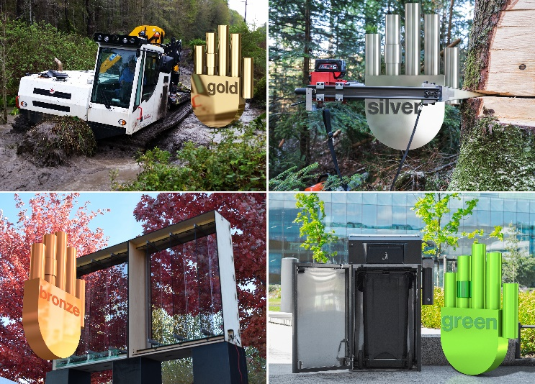
Picture PM2621-1
The winners of the 10th manus awards: gold for PowerBully by Kässbohrer Geländefahrzeug AG, silver for a radio-controlled felling wedge, and bronze for a sun protection facade system with a shape memory alloy. The new green manus went to Finbin for its intelligent, solar-powered rubbish bin.
(Source: igus GmbH)

PRESS CONTACT:  Oliver Cyrus  Head of PR and Advertising  Anja Görtz-Olscher  PR and Advertising  igus® GmbH  Spicher Str. 1a  51147 Cologne  Tel. 0 22 03 / 96 49-459 or -7153  Fax 0 22 03 / 96 49-631  ocyrus@igus.net  agoertz@igus.net  www.igus.eu/press | ABOUT IGUS:  igus GmbH develops and produces motion plastics. These lubrication-free, high-performance polymers improve technology and reduce costs wherever things move. In energy supplies, highly flexible cables, plain and linear bearings as well as lead screw technology made of tribo-polymers, igus is the worldwide market leader. The family-run company based in Cologne, Germany, is represented in 35 countries and employs 3,800 people across the globe. In 2019, igus generated a turnover of €764 million. Research in the industry's largest test laboratories constantly yields innovations and more security for users. 234,000 articles are available from stock and the service life can be calculated online. In recent years, the company has expanded by creating internal startups, e.g. for ball bearings, robot drives, 3D printing, the RBTX platform for Lean Robotics and intelligent "smart plastics" for Industry 4.0. Among the most important environmental investments are the "chainge" programme – recycling of used e-chains - and the participation in an enterprise that produces oil from plastic waste. (Plastic2Oil).

The terms "igus", “Apiro”, "chainflex", "CFRIP", "conprotect", "CTD", “drygear”, "drylin", "dry-tech", "dryspin", "easy chain", "e-chain", "e-chain systems", "e-ketten", "e-kettensysteme", "e-skin", "e-spool”, "flizz", “ibow”, “igear”, "iglidur", "igubal", “kineKIT”, "manus", "motion plastics", "pikchain", "plastics for longer life", "readychain", "readycable", “ReBeL”, "speedigus", "tribofilament“, "triflex", "robolink", “xirodur”, and "xiros" are protected by trademark laws in the Federal Republic of Germany and internationally, where applicable.

