Fast and lubrication-free: new xiros film guide roller for labelling technology
Black guide roller with smooth-running polymer ball bearings saves up to 48 per cent weight and 42 per cent mass inertia

They divert films or labels: guide rollers with ball bearings. Mainly used, so far, in clear anodised aluminium, the new black guide roller from igus now provides a real sensation in packaging and labelling technology. The ready-to-install system is convincing not only visually, but also technically. It consists of black anodised aluminium tubes and maintenance-free, smooth-running xiros polymer ball bearings.

xiros polymer ball bearings are lubrication-free, maintenance-free, hygienic and have a very low breakaway torque. Due to these specifications, they are mainly used in the field of packaging and food technology. As fully assembled systems with a tube made of aluminium, carbon or PVC, the ball bearings prove their worth as guide rollers for deflecting films and labels or for conveying goods. By using wear-resistant high-performance polymers and thin-walled tubes, they provide a weight saving of up to 48 per cent compared to metallic solutions. Their mass inertia is 42 per cent lower, and therefore the energy required for acceleration is considerably lower and the rollers reach the conveying speed faster. The igus range has now been expanded with a new black aluminium roller. "The idea for the black design arose from a customer enquiry. The technical specifications of our classic aluminium rollers were already very convincing, but black visible parts were desired for one labelling series", explains Marcus Semsroth, Head of the xiros polymer ball bearing division at igus GmbH. The solution: black anodised aluminium for the roller and black xirodur S180 fixed flange ball bearings made of polymer. "This soon resulted in a product that met the customer's requirements in terms of technology, price and appearance", says Semsroth. In addition to this, the new black roller also offers further areas of application. This allows the roller to work easily together with camera systems, as it doesn't reflect light.

Custom guide roller configured in two steps
igus has developed the guide rollers expert for the quick selection of a suitable guide roller. In the online tool, the user only has to specify the outer and inner diameter as well as the length of the roller, the load, the load case and the ambient temperature. By entering the acting force and the degree of wrap around, the online expert calculates the resulting force on the roller and recommends the appropriate tube materials. In the second step, the user can select their guide roller based on the deflection, weight and price data, download the configuration CAD data and order the roller directly online.

Caption:

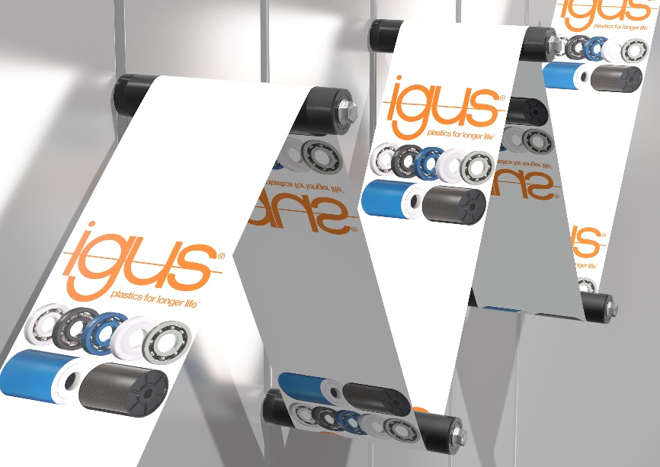
Picture PM3620-1
Easy and lubrication-free guidance of labels with xiros polymer ball bearing in the new black guide roller. (Source: igus GmbH)

PRESS CONTACT:  Oliver Cyrus  Head of PR and Advertising  Anja Görtz-Olscher  PR and Advertising  igus® GmbH  Spicher Str. 1a  51147 Cologne  Tel. 0 22 03 / 96 49-459 or -7153  Fax 0 22 03 / 96 49-631  ocyrus@igus.net  agoertz@igus.net  www.igus.eu/press | ABOUT IGUS:  igus GmbH is a global leading manufacturer of energy chain systems and polymer plain bearings. The Cologne-based family business has offices in 35 countries and employs 4,150 people around the world. In 2019, igus generated a turnover of 764 million euros from motion plastics, plastic components for moving applications. igus operates the largest test laboratories and factories in its sector to offer customers quick turnaround times on innovative products and solutions tailored to their needs.

The terms "igus", “Apiro”, "chainflex", "CFRIP", "conprotect", "CTD", “drygear”, "drylin", "dry-tech", "dryspin", "easy chain", "e-chain", "e-chain systems", "e-ketten", "e-kettensysteme", "e-skin", "e-spool”, "flizz", “ibow”, “igear”, "iglidur", "igubal", “kineKIT”, "manus", "motion plastics", "pikchain", "plastics for longer life", "readychain", "readycable", “ReBeL”, "speedigus", "triflex", "robolink", “xirodur”, and "xiros" are protected by trademark laws in the Federal Republic of Germany and internationally, where applicable.

