**igus develops a two-component injection-moulded plain bearing for high mechanical loads**

**Injection-moulded iglidur Q3E plain bearing ensures lubrication-free maximum load capacity performance in efficient high-volume production**

**New to the agricultural and construction machinery industry: with the new iglidur Q3E plain bearing, igus has - for the first time - managed to manufacture heavy-duty bearings made of two layers of high-performance plastic using a cost-effective injection-moulding process. Plastic-based, multi-layer structures previously required the winding process, which is more expensive for high volumes.**

If an excavator moves hundreds of kilograms of sand, enormous loads act on the bucket's bearing points. So far, igus has primarily used igutex-series plain bearings to handle this. The bearings are made of different materials and manufactured in a winding process. Integrated solid lubricants ensure low-friction dry operation. The outer layer provides enormous strength. "We have now succeeded in implementing a multi-layer structure using the injection-moulding process, combining materials with complementary specifications," says Uwe Sund, Product Manager iglidur Heavy-Duty Bearings. The result was the iglidur Q3E series. "The new technology enables us to mass-produce multi-component heavy-duty bearings using very cost-effective injection moulding."

**The challenge: inject and fuse two materials in one operation**

The new iglidur Q3E series is the result of intensive cooperation between igus material development and the specialists from our in-house tool making. "While developing iglidur Q3E, our goal was to implement a multi-part structure similar to the igutex series - with iglidur Q3 high-performance plastic for a tribologically optimised core and a strongly reinforced polymer for a mechanically high-strength shell," says Sund. The biggest challenge was to process the two different materials in the injection-moulding process so that two components become one. This combines the advantages of the two materials. "We are able to do this with the multi-component injection-moulding process with correspondingly complex, sophisticated injection-moulding tools."

**Robust load-bearing capacity with convincing sliding properties**

Heavy-duty applications normally require bearings made of metal or fibre composite bushings, for example in construction and agricultural machinery. To reduce costs, the plain bearings made of iglidur Q3E are used as their maximum dynamic surface pressure is 75MPa. "This means that we can cover many heavy-duty applications with iglidur Q3E," says Sund. The decisive advantage is that the plain bearings require no lubricating grease. Microscopic solid lubricants are integrated into the polymer of the inner layer and released gradually over the bearing's service life. "Construction and agricultural machinery maintenance are two areas where lubricating the bearing points is one of the most time-consuming tasks," says Sund. "By switching to iglidur Q3E or igutex, users can reduce maintenance costs and extend machine service life. Neglecting lubrication for classic metal bearings is a frequent cause of expensive damage to shafts and plain bearings."

**Caption:**

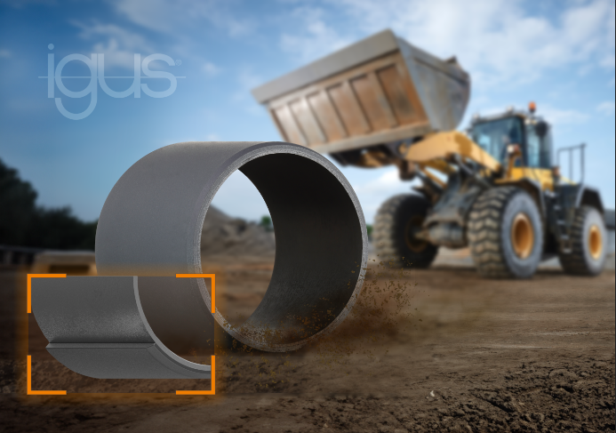

**Picture PM4423-1**

Hard shell and wear-resistant core: the new cost-effective iglidur Q3E plain bearing supports heavy loads without lubrication. (Source: igus GmbH)

**PRESS CONTACT:**

Alexa Heinzelmann

Head of International Marketing

igus® GmbH

Spicher Str. 1a

51147 Cologne

Tel. 0 22 03 / 96 49-7272

[aheinzelmann@igus.net](mailto:aheinzelmann@igus.net)

[www.igus.eu/press](http://www.igus.eu/press)

**ABOUT IGUS:**

igus GmbH develops and produces motion plastics. These lubrication-free, high-performance polymers improve technology and reduce costs wherever things move. In energy supplies, highly flexible cables, plain and linear bearings as well as lead screw technology made of tribo-polymers, igus is the worldwide market leader. The family-run company based in Cologne, Germany, is represented in 31 countries and employs 4,600 people across the globe. In 2022, igus generated a turnover of €1,15 billion. Research in the industry's largest test laboratories constantly yields innovations and more security for users. 234,000 articles are available from stock and the service life can be calculated online. In recent years, the company has expanded by creating internal startups, e.g. for ball bearings, robot drives, 3D printing, the RBTX platform for Lean Robotics and intelligent "smart plastics" for Industry 4.0. Among the most important environmental investments are the "chainge" programme – recycling of used e-chains - and the participation in an enterprise that produces oil from plastic waste.

The terms "igus", “Apiro”, "chainflex", "CFRIP", "conprotect", "CTD", “drygear”, "drylin", "dry-tech", "dryspin", "easy chain", "e-chain", "e-chain systems", "e-ketten", "e-kettensysteme", "e-skin", "e-spool”, "flizz", “ibow”, “igear”, "iglidur", "igubal", “kineKIT”, "manus", "motion plastics", "pikchain", "plastics for longer life", "readychain", "readycable", “ReBeL”, "speedigus", "tribofilament“, "triflex", "robolink", “xirodur”, and "xiros" are protected by trademark laws in the Federal Republic of Germany and internationally, where applicable.