Yesterday's waste, today's bicycle: igus shows German Chancellor Scholz a world first made of all-plastic at the Hannover Messe
The concept of the plastic bicycle without rust, maintenance and lubricants enables urban sustainable mobility

Hanover/Cologne, 30 May 2022 - German Chancellor Olaf Scholz, accompanied by Portuguese Prime Minister António Costa, visited the stand of plastics specialist igus on the first day of the Hannover Messe. The focus of the conversation was the igus:bike, an innovative concept for sustainable urban mobility of the future.

At Hannover Messe 2022, igus is presenting a world first: the concept of a robust and durable bicycle made almost entirely of plastic - from the frame to the bearings to the toothed belt. A high proportion of the raw materials required for this can be covered by recycling plastic waste. During the tour of the world's largest industrial show for automation and Industry 4.0, Frank Blase, CEO of igus, presented the innovative igus:bike to German Chancellor Olaf Scholz and Portuguese Prime Minister António Costa. "We think big and start small now. With our dream of an all-plastic bicycle, there is an opportunity to change the bicycle industry for the long term," says Frank Blase.

The igus:bike platform offers the global bicycle industry the opportunity to build a very different kind of bike, in many local locations around the globe. One partner is the Dutch start-up MTRL, which will start producing and selling an adult bike for cities and a children's model by the end of the year. The market launch in Germany will take place at the beginning of 2023. Further variants, for example as an e-bike, are also being planned. In the future, the all-plastic bicycle will be available in a version made of new plastic as well as in a version made of 100 per cent recycled material. MTRL is planning local production sites around the world near plastic landfills. Frank Blase "The world is changing rapidly. We want to shape this change with innovative ideas. If, as with the igus:bike, plastic becomes a valuable and sustainable resource, then the way we deal with plastic can also change positively in many other areas."

More information on the igus:bike can be found at:
www.igus.eu/press
www.igus.bike

The video of the visit is available on YouTube: https://youtu.be/SoOdJqVlllU

Caption:

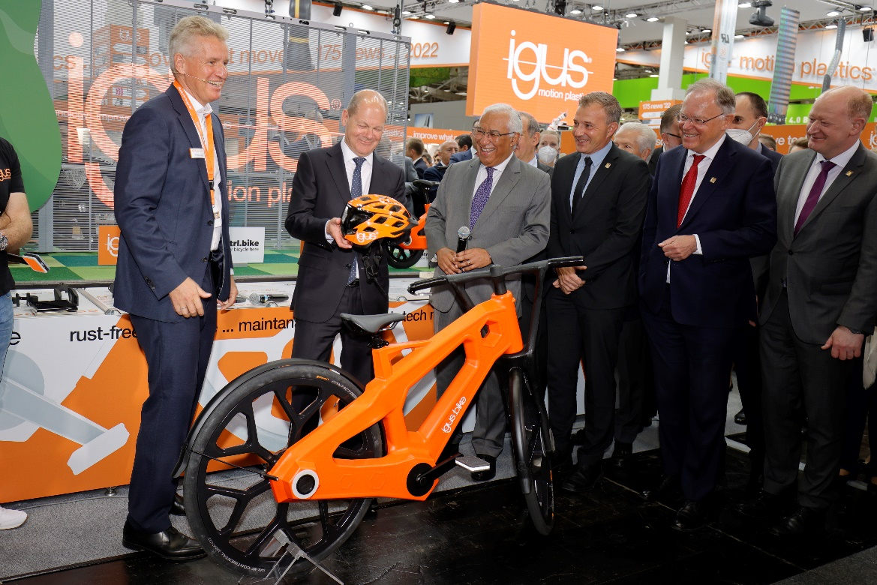
Image PM2822-1
igus Managing Director Frank Blase shows the igus:bike to German Chancellor Olaf Scholz and Portuguese Prime Minister António Costa. (Source: igus GmbH)

PRESS CONTACT:

Alexa Heinzelmann
Head of International Marketing

igus® GmbH
Spicher Str. 1a
51147 Cologne
Tel. 0 22 03 / 96 49-7272
aheinzelmann@igus.net
www.igus.eu/press

ABOUT IGUS:

igus GmbH develops and produces motion plastics. These lubrication-free, high-performance polymers improve technology and reduce costs wherever things move. In energy supplies, highly flexible cables, plain and linear bearings as well as lead screw technology made of tribo-polymers, igus is the worldwide market leader. The family-run company based in Cologne, Germany, is represented in 35 countries and employs 4,900 people across the globe. In 2021, igus generated a turnover of €961 million. Research in the industry's largest test laboratories constantly yields innovations and more security for users. 234,000 articles are available from stock and the service life can be calculated online. In recent years, the company has expanded by creating internal startups, e.g. for ball bearings, robot drives, 3D printing, the RBTX platform for Lean Robotics and intelligent "smart plastics" for Industry 4.0. Among the most important environmental investments are the "chainge" programme – recycling of used e-chains - and the participation in an enterprise that produces oil from plastic waste.

The terms "igus", “Apiro”, "chainflex", "CFRIP", "conprotect", "CTD", “drygear”, "drylin", "dry-tech", "dryspin", "easy chain", "e-chain", "e-chain systems", "e-ketten", "e-kettensysteme", "e-skin", "e-spool”, "flizz", “ibow”, “igear”, "iglidur", "igubal", “kineKIT”, "manus", "motion plastics", "pikchain", "plastics for longer life", "readychain", "readycable", “ReBeL”, "speedigus", "tribofilament“, "triflex", "robolink", “xirodur”, and "xiros" are protected by trademark laws in the Federal Republic of Germany and internationally, where applicable.

