Heavy loads are no problem for the new igutex TX3 fibre wound material
igus launches a new lubrication-free material, the endurance runner which is ideal for heavy-duty applications.

In applications with loads of more than 80Mpa, plain bearings made of thermoplastic materials can be pushing their limits. igus has expanded the existing range of standard plain bearings with the new igutex fibre wound plain bearing series. The series displays its strength in heavy-duty areas such as construction machinery or hoists. The latest development in the product family is the material igutex TX3. It offers an even higher running performance with high dynamic forces than previous igutex bearings.

With the igutex product family, igus has developed plain bearings made from high-strength fibre wound materials. They are used where very high loads occur and where injection-moulded plain bearings may reach their load limits. "This can be construction machinery, the agricultural industry or applications in container cranes or in the offshore sector," explains Uwe Sund, Product Manager for Heavy-Duty Bearings at igus GmbH. Extremely strong filaments and their special winding technology structure ensure maximum resilience. A robust fibreglass fabric serves as the outer shell, while a tribologically optimised inner layer reduces friction on the shaft and gives a smooth gliding surface. "Our igutex materials are ideal in applications that have to absorb up to 200MPa," explains Sund. With the new igutex TX3, igus has now developed a material that offers an even longer service life, especially under extreme dynamic loads and where increasing and decreasing loads may occur, for example, in the hydraulic connections of excavator shovels. igutex TX3 also enables the use of rough or soft shaft materials, such as Cf53. As with all iglidur plain bearings, igutex TX3 is self-lubricating and is completely dry running. Solid lubricants, which are integrated in the gliding layer of the fibre wound bearing, enable the best possible coefficients of friction without the need for external lubrication. Users can therefore save costs on oil, grease and maintenance. Additionally, no lubricants are released into the environment, offering a sustainability element.
The new test winner
igutex TX3 was thoroughly tested at the indoor and outdoor test rigs in the igus test laboratory in Cologne. Tests showed that from among the igutex family, the igutex TX3 plain bearing on a Cf53 hard chrome-plated shaft achieved the best values in the pivoting application with 100MPa. The new igutex TX3 fibre wound plain bearings are in stock and are part of the standard product range with inner diameters of 20 to 80 millimetres. Custom-made products with additional diameters are also available on request.

PRESS CONTACT:

Alexa Heinzelmann
Head of International Marketing

igus® GmbH
Spicher Str. 1a
51147 Cologne
Tel. 0 22 03 / 96 49-7272
aheinzelmann@igus.net
www.igus.eu/press

ABOUT IGUS:

igus GmbH develops and produces motion plastics. These lubrication-free, high-performance polymers improve technology and reduce costs wherever things move. In energy supplies, highly flexible cables, plain and linear bearings as well as lead screw technology made of tribo-polymers, igus is the worldwide market leader. The family-run company based in Cologne, Germany, is represented in 31 countries and employs 4,600 people across the globe. In 2022, igus generated a turnover of €1,15 billion. Research in the industry's largest test laboratories constantly yields innovations and more security for users. 234,000 articles are available from stock and the service life can be calculated online. In recent years, the company has expanded by creating internal startups, e.g. for ball bearings, robot drives, 3D printing, the RBTX platform for Lean Robotics and intelligent "smart plastics" for Industry 4.0. Among the most important environmental investments are the "chainge" programme – recycling of used e-chains - and the participation in an enterprise that produces oil from plastic waste.

The terms "igus", “Apiro”, "chainflex", "CFRIP", "conprotect", "CTD", “drygear”, "drylin", "dry-tech", "dryspin", "easy chain", "e-chain", "e-chain systems", "e-ketten", "e-kettensysteme", "e-skin", "e-spool”, "flizz", “ibow”, “igear”, "iglidur", "igubal", “kineKIT”, "manus", "motion plastics", "pikchain", "plastics for longer life", "readychain", "readycable", “ReBeL”, "speedigus", "tribofilament“, "triflex", "robolink", “xirodur”, and "xiros" are protected by trademark laws in the Federal Republic of Germany and internationally, where applicable.

Caption:

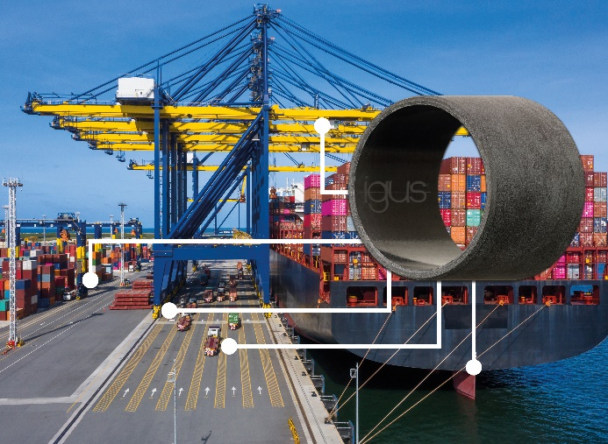
Picture PM2223-1
Especially for applications with high dynamic forces, such as in hoists, the new material igutex TX3 offers an even higher running performance. (Source: igus GmbH)

