Video: ready-to-connect cables soldered to a high quality with advanced soldering stations at igus
High-end equipment and technically trained personnel enable optimum soldering results even with manual work

Ready-to-connect harnessed and quality-checked cables within three to five days and much faster upon request: this is what igus promises with its readycable cables, which are produced in Cologne on a manufacturer-specific or customer-specific basis. Besides industrial crimping technology, igus also relies on the widely used soldering to connect the connectors to the cores of the cables. As soldering is a manual process, the quality of the soldering results is subject to fluctuations that can affect the machine's function. In order to deliver soldering work at a consistently high level, igus has now invested in additional high-performance soldering stations. With the help of the new soldering stations, specialised employees achieve higher quality soldering results faster and more reliably. The complementary soldering stations offer the possibility of an exact digital presetting of the soldering temperature, which does not change during the entire soldering process. The solder is automatically applied to the adaptable soldering tip by the integrated heating element that delivers the heat directly to the solder. At the touch of a button, further solder is added and the solder joint is set with pinpoint accuracy. High-resolution and true-colour optics with up to 48x zoom and a calibrated inspection monitor are used to check the soldering results. The new soldering stations shorten throughput times, increase productivity and thus enable more favourable prices for the purchaser. igus also passes on cost benefits to customers by purchasing connectors in bulk. igus offers over 4,800 harnessed drive cables to match 24 different manufacturer standards. All readycable units are tested and inspected in our own 3,800 square metre laboratory and have a guarantee of up to 36 months.

Caption:
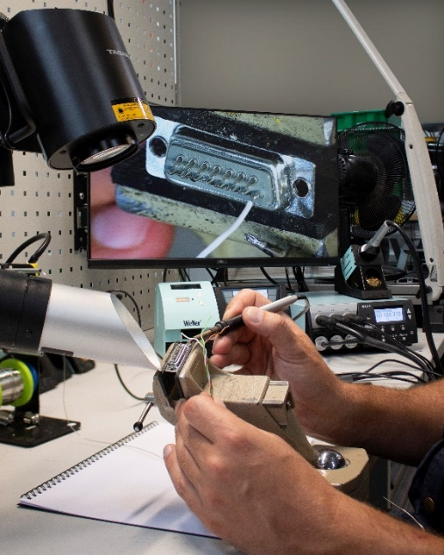
Picture PM6720-1
The new soldering stations at igus ensure reproducible and high-quality soldering results. At the same time, they simplify the work of trained personnel and increase throughput times in production. (Source: igus GmbH)

PRESS CONTACT:  Oliver Cyrus  Head of PR and Advertising  Anja Görtz-Olscher  PR and Advertising  igus® GmbH  Spicher Str. 1a  51147 Cologne  Tel. 0 22 03 / 96 49-459 or -7153  Fax 0 22 03 / 96 49-631  ocyrus@igus.net  agoertz@igus.net  www.igus.eu/press | ABOUT IGUS:  igus GmbH develops and produces motion plastics. These lubrication-free, high-performance polymers improve technology and reduce costs wherever things move. In energy supplies, highly flexible cables, plain and linear bearings as well as lead screw technology made of tribo-polymers, igus is the worldwide market leader. The family-run company based in Cologne, Germany, is represented in 35 countries and employs 3,800 people across the globe. In 2019, igus generated a turnover of €764 million. Research in the industry's largest test laboratories constantly yields innovations and more security for users. 234,000 articles are available from stock and the service life can be calculated online. In recent years, the company has expanded by creating internal startups, e.g. for ball bearings, robot drives, 3D printing, the RBTX platform for Lean Robotics and intelligent "smart plastics" for Industry 4.0. Among the most important environmental investments are the "chainge" programme – recycling of used e-chains - and the participation in an enterprise that produces oil from plastic waste. (Plastic2Oil).

The terms "igus", “Apiro”, "chainflex", "CFRIP", "conprotect", "CTD", “drygear”, "drylin", "dry-tech", "dryspin", "easy chain", "e-chain", "e-chain systems", "e-ketten", "e-kettensysteme", "e-skin", "e-spool”, "flizz", “ibow”, “igear”, "iglidur", "igubal", “kineKIT”, "manus", "motion plastics", "pikchain", "plastics for longer life", "readychain", "readycable", “ReBeL”, "speedigus", "tribofilament“, "triflex", "robolink", “xirodur”, and "xiros" are protected by trademark laws in the Federal Republic of Germany and internationally, where applicable.

