New igus polymer spherical ball improves food safety
The new iglidur A181 spherical ball material triples the igubal FC joint system's wear resistance

To make food industry machines and systems even safer, igus is launching a new standard with the iglidur A181 high-performance plastic as a spherical ball material for the igubal Food Contact (FC) joint system. The spherical ball has three times the wear resistance of its iglidur FC180 predecessor, costs 25% less and is lubrication-free, maintenance-free, hygienic and compliant with FDA and EU 10/2011.

"Is there anything we can still eat without worrying about it?" More and more consumers are asking this question in the face of regular product recalls. Food manufacturers constantly struggle with hazardous contaminants, often tiny splinters of broken processing machine components. "Bottling plant, meat-processing machine or packaging system: manufacturers must continuously improve their equipment's robustness and reliability while increasing the detectability of tiny contaminants," says Dennis Steffen, Product Manager igubal Spherical Bearings at igus. "We support manufacturers in this food safety optimisation effort by continuously developing igubal FC joint system pillow block bearings, rod ends and fixed flange bearings. Our latest innovation is a spherical ball made of the new iglidur A181 material."
Three times the wear resistance at just three quarters of the cost of the previous version
The igubal FC joint system housing is still made of igumid FC - a robust, corrosion-free high-performance plastic that is resistant to moisture, acids, alkalis and UV radiation. Recently, however, the spherical ball inserted into the housing has been switched from FC180 to iglidur A181 - a successor that features high wear resistance. "Thanks to new material composition, the spherical ball is up to three times as wear-resistant on stainless steel shafts as the previous FC180 version," says Steffen. "This makes movements in the machine even safer and more reliable." Like all igus products, igubal spherical bearings prove their longevity in numerous tests in the 3,800sqm igus test laboratory. At the same time, the price was reduced by 25% - a positive side effect that makes it easier for many mechanical engineers to replace classic metal joint systems. "The price advantage is now enormous. igubal FC costs up to 85% less than stainless-steel variants."
Eliminating lubricants improves machine and system hygiene
However, the igubal FC joint system with the new A181 spherical ball not only costs less than metal counterparts, but also improves the hygiene of machinery and equipment in the food industry. Unlike metallic spherical bearings, it requires no external lubricant that dirt and dust can stick to, forming gooey deposits and a potential contamination risk. Instead, igus incorporates a solid lubricant into the material that is released automatically over time, ensuring low-friction, hygienic dry operation. Both the housing and the new spherical ball material are thus compliant with FDA and EU 10/2011. "The approval of the FDA, with one of the strictest hygiene guidelines in the world, and compliance with EU Directive 10/2011 confirm the joint system's high level of hygiene," Steffen says. To further improve hygiene, both bearing housing and spherical ball are dyed blue, a colour on which food residue and mould spores can be quickly identified during cleaning checks and that facilitates optical detection in the case of machine damage. Food-compliant, detectable additives are also integrated into the housing material. In an emergency, they allow metal detectors to find even the tiniest fragments - in the range of one tenth of a gramme.

Caption:

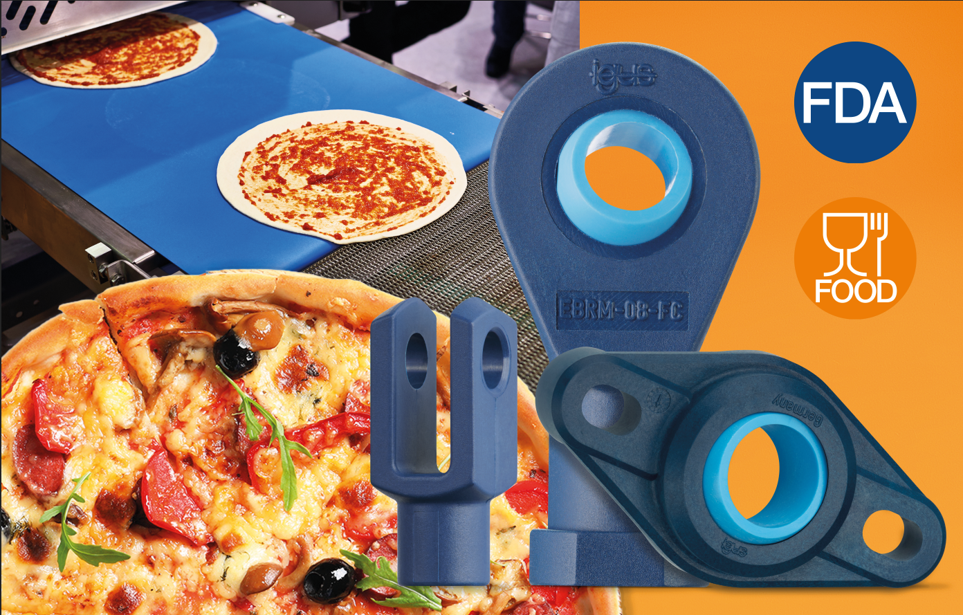
Picture PM4322-1
More food safety with lubrication-free motion plastics from igus: thanks to the new A181 spherical ball, the igubal FC joint system is now three times as wear-resistant and costs 25% less. (Source: igus GmbH)

PRESS CONTACT:

Alexa Heinzelmann
Head of International Marketing

igus® GmbH
Spicher Str. 1a
51147 Cologne
Tel. 0 22 03 / 96 49-7272
aheinzelmann@igus.net
www.igus.eu/press

ABOUT IGUS:

igus GmbH develops and produces motion plastics. These lubrication-free, high-performance polymers improve technology and reduce costs wherever things move. In energy supplies, highly flexible cables, plain and linear bearings as well as lead screw technology made of tribo-polymers, igus is the worldwide market leader. The family-run company based in Cologne, Germany, is represented in 35 countries and employs 4,900 people across the globe. In 2021, igus generated a turnover of €961 million. Research in the industry's largest test laboratories constantly yields innovations and more security for users. 234,000 articles are available from stock and the service life can be calculated online. In recent years, the company has expanded by creating internal startups, e.g. for ball bearings, robot drives, 3D printing, the RBTX platform for Lean Robotics and intelligent "smart plastics" for Industry 4.0. Among the most important environmental investments are the "chainge" programme – recycling of used e-chains - and the participation in an enterprise that produces oil from plastic waste.

The terms "igus", “Apiro”, "chainflex", "CFRIP", "conprotect", "CTD", “drygear”, "drylin", "dry-tech", "dryspin", "easy chain", "e-chain", "e-chain systems", "e-ketten", "e-kettensysteme", "e-skin", "e-spool”, "flizz", “ibow”, “igear”, "iglidur", "igubal", “kineKIT”, "manus", "motion plastics", "pikchain", "plastics for longer life", "readychain", "readycable", “ReBeL”, "speedigus", "tribofilament“, "triflex", "robolink", “xirodur”, and "xiros" are protected by trademark laws in the Federal Republic of Germany and internationally, where applicable.

