From idea to integration: broad partner network supports customers with their Low Cost Automation
igus is working with manufacturers and integrators to further expand its service and range for cost-effective automation

Low Cost Automation reduces the barriers to getting started with automation and gives special assistance to small and medium-sized companies in increasing their competitiveness. To this end, motion plastics specialist igus has built up a broad network of 55 robotics providers and 40 integrators over the past three years - and new partners are constantly being added.

As a result of continuous developments and product innovations, affordable robotics has become especially interesting for small and medium-sized companies. And the number of offers on the market is increasing. For instance, igus Low Cost Automation represents a broad portfolio of articulated arm, linear, delta and SCARA robots. Product modularity means that single components or individual complete solutions can be assembled according to the build-or-buy principle. The focus is always on a low entry-level price and quick payback. This is where igus high-performance plastics play to their strengths. They are tribologically optimised and especially durable, lightweight, lubrication-free and maintenance-free, and cost-effective to produce.

The most cost-effective solution that works
Over the past three years, igus has built up a broad, constantly growing partner network. As part of the LCA partner programme, the motion plastics specialist works with integrators who provide customers with additional expertise, experience with end customer projects, and joint project experience. Says Mühlens, "We started with seven partners around two years ago, and we now have almost 100. In order to refer interested parties to competent integration partners in their area, we are constantly expanding our network. Together, we can offer our customers a wide range of automation solutions - focussing on applications with a total investment volume of less than €45,000. We work with our customers to select the ideal integrator for the application in order to find the best and most cost-effective solution." Typical services include integrating a control system into existing machines, setting up and commissioning robots, evaluating safety measures or, if there is simply no capacity, providing the capability of assembling machines on site.

Experience Low Cost Automation live on site
Like igus, many integrators have set up a customer testing area so that customers can experience igus Low Cost Automation live. "Nothing is more convincing than being able to experience robot programming or gripper adaptations yourself on site in just 30 minutes. That's why we have over 30 customer visits a week in Cologne alone", says Mühlens. The range of test areas is wide: from a delta robot cell at ITQ GmbH in Garching near Munich to a 150-square-metre area with four robots and linear robot axes at Provitec near Heilbronn to a 1,400-square-metre customer testing area at Truphysics in Stuttgart with 300 square metres of space just for igus products. With its own Low Cost Automation roadshow, igus works with the integrator partners to organise events or visit customers directly on site. "We have already organised roadshow events in Germany, Denmark, Sweden, Finland, Poland, Belgium, France, Switzerland, and the Netherlands, attracting a total of around 3,500 visitors. The aim of the roadshow is to always automate directly on site," says Mühlens.

RBTX online marketplace: new partners are adding more and more new products to the range
Since 2019, users have also had access to the igus RBTX marketplace - an online marketplace that brings users and manufacturers of low-cost robotics together. Alexander Mühlens: "At RBTX.com, interested parties can currently find compatible components from a total of 78 partners. The marketplace currently has 100 low-cost applications with parts lists and hardware and software compatibility for price transparency. As an open marketplace, we are always interested in new partners for the low-cost robotics mission, so that we can ultimately provide interested parties with even more individual solutions for their specific application." Partners benefit from a new digital sales channel and can expand their customer base and open up new markets - a win for everyone involved.

Caption:

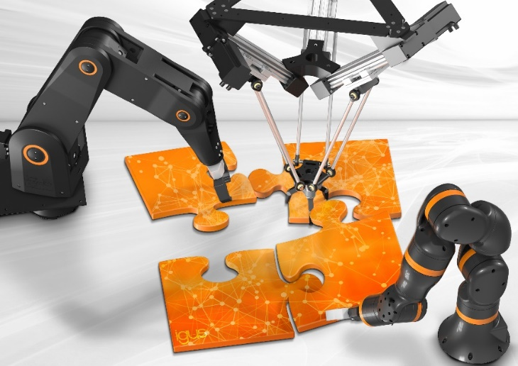
Picture PM7322-1
Robot manufacturers, component providers, integrators: the individual puzzle pieces are used to create a Low Cost Automation solution tailored to the customer that pays for itself in 3 to 12 months. (Source: igus GmbH)

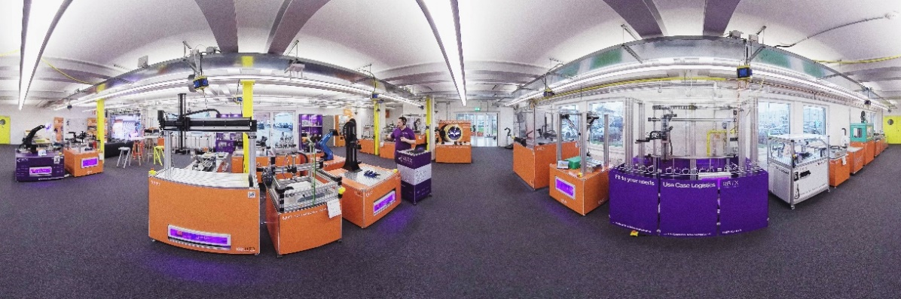
Picture PM7322-2
Test before you invest: Thanks to the customer testing areas, interested parties can find out how quickly and easily robot programming works before they invest and can have their individual Low Cost Automation application tested. (Source: igus GmbH)

PRESS CONTACT:

Alexa Heinzelmann
Head of International Marketing

igus® GmbH
Spicher Str. 1a
51147 Cologne
Tel. 0 22 03 / 96 49-7272
aheinzelmann@igus.net
www.igus.eu/press

ABOUT IGUS:

igus GmbH develops and produces motion plastics. These lubrication-free, high-performance polymers improve technology and reduce costs wherever things move. In energy supplies, highly flexible cables, plain and linear bearings as well as lead screw technology made of tribo-polymers, igus is the worldwide market leader. The family-run company based in Cologne, Germany, is represented in 31 countries and employs 4,900 people across the globe. In 2021, igus generated a turnover of €961 million. Research in the industry's largest test laboratories constantly yields innovations and more security for users. 234,000 articles are available from stock and the service life can be calculated online. In recent years, the company has expanded by creating internal startups, e.g. for ball bearings, robot drives, 3D printing, the RBTX platform for Lean Robotics and intelligent "smart plastics" for Industry 4.0. Among the most important environmental investments are the "chainge" programme – recycling of used e-chains - and the participation in an enterprise that produces oil from plastic waste.

The terms "igus", “Apiro”, "chainflex", "CFRIP", "conprotect", "CTD", “drygear”, "drylin", "dry-tech", "dryspin", "easy chain", "e-chain", "e-chain systems", "e-ketten", "e-kettensysteme", "e-skin", "e-spool”, "flizz", “ibow”, “igear”, "iglidur", "igubal", “kineKIT”, "manus", "motion plastics", "pikchain", "plastics for longer life", "readychain", "readycable", “ReBeL”, "speedigus", "tribofilament“, "triflex", "robolink", “xirodur”, and "xiros" are protected by trademark laws in the Federal Republic of Germany and internationally, where applicable.

