Green electricity from traditional windmills
igus supports Sailwind 4, a student project, with €10,000 and free components

In the past, traditional windmills drove mill grinders and irrigation pumps, but in future they are to produce green electricity. For this purpose, students at the HTWG Konstanz, a university of applied sciences, are installing high-tech components. igus is supporting the Sailwind 4 project with €10,000 and providing the young engineers with lubrication-free linear guides and polymer bearings, which will ensure that windmill operation requires little maintenance.

Wind turbines are being built all over the world as part of the global energy transition. However, there are places where the turbines just don't fit. At the same time, nature conservation often thwarts projects. But does that mean giving up wind power? Not if the students at the HTWG Konstanz have a say. They hope to use small windmills to generate green electricity. Their Sailwind 4 project is focussed on recreating a Greek sail-driven windmill, one of the oldest known devices for using wind energy and today a cultural asset in the Mediterranean region from Turkey to France. Previously used primarily for grinding grain and legumes, these windmills will produce green electricity with a generator in future. The advantage is that there are already thousands of mills that can be retrofitted as miniature green power plants.

igus is the first sponsor
igus is enthusiastic about the compact wind power plant. “We intend to make our buildings and production CO₂-neutral by 2025, but we are also thinking beyond company boundaries. Therefore, we are supporting Sailwind 4 with €10,000 and providing the students with free components to build the new windmills,” says Tobias Vogel, CEO Plain Bearings and Linear Technology at igus. “igus is known for its commitment to innovative projects initiated by secondary school and university students,” says Professor Dieter Schwechten, who, together with Professor Ditmar Ihlenburg, initiated Sailwind 4. “We are very pleased to have igus as our first partner and hope to gain more project supporters from the industry.”
Lubrication-free igus components reduce maintenance cost and effort
If everything goes according to plan, the students will start building the first windmill in October. It will retain the typical visual characteristics of the historical model: a cylindrical tower, a tapered roof structure and the sail rods on the rotating main shaft. The engineers will attach high-tech sails to the latter, and connect the shafts to a power generator. A wind speed of 14m/s should allow a rotor 4m in diameter to generate 5kWp of electricity. The small wind generator could also be combined with a photovoltaic system and battery storage. “Local, sustainable power generated with wind and sun has great advantages for many regions because the two complement each other well in terms of climate,” says Schwechten. The systems are to work with as little monitoring and maintenance as possible. “We have set ourselves the mechatronic task of completely automating windmill operation, which is how large wind turbines work,” says Schwechten. “After all, there are no millers to operate windmills today.” This is where the components igus provides come into play. They include linear guides for motorised sail trimming, slewing ring bearing support for the rotor and a variety of plain bearings made of high-performance plastics. All igus components are robust, fail-safe, and corrosion-free and require no lubrication or maintenance. This is a big advantage for upgrading old windmills in the Mediterranean.

Caption:

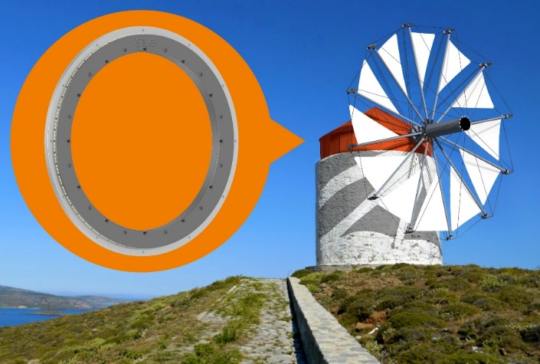
Picture PM5223-1
High-tech meets nostalgia: the HTWG Konstanz's Sailwind 4 project aims at using old windmills to generate sustainable electricity. igus is supporting the idea financially and with lubrication-free, maintenance-free components. (Source: igus GmbH)

PRESS CONTACT:

Alexa Heinzelmann
Head of International Marketing

igus® GmbH
Spicher Str. 1a
51147 Cologne
Tel. 0 22 03 / 96 49-7272
aheinzelmann@igus.net
www.igus.eu/press

ABOUT IGUS:

igus GmbH develops and produces motion plastics. These lubrication-free, high-performance polymers improve technology and reduce costs wherever things move. In energy supplies, highly flexible cables, plain and linear bearings as well as lead screw technology made of tribo-polymers, igus is the worldwide market leader. The family-run company based in Cologne, Germany, is represented in 31 countries and employs 4,600 people across the globe. In 2022, igus generated a turnover of €1,15 billion. Research in the industry's largest test laboratories constantly yields innovations and more security for users. 234,000 articles are available from stock and the service life can be calculated online. In recent years, the company has expanded by creating internal startups, e.g. for ball bearings, robot drives, 3D printing, the RBTX platform for Lean Robotics and intelligent "smart plastics" for Industry 4.0. Among the most important environmental investments are the "chainge" programme – recycling of used e-chains - and the participation in an enterprise that produces oil from plastic waste.

The terms "igus", “Apiro”, "chainflex", "CFRIP", "conprotect", "CTD", “drygear”, "drylin", "dry-tech", "dryspin", "easy chain", "e-chain", "e-chain systems", "e-ketten", "e-kettensysteme", "e-skin", "e-spool”, "flizz", “ibow”, “igear”, "iglidur", "igubal", “kineKIT”, "manus", "motion plastics", "pikchain", "plastics for longer life", "readychain", "readycable", “ReBeL”, "speedigus", "tribofilament“, "triflex", "robolink", “xirodur”, and "xiros" are protected by trademark laws in the Federal Republic of Germany and internationally, where applicable.

