Guaranteed to be particle-free, unique igus cleanroom laboratory for ISO Class 1 components
New test laboratory built by the Fraunhofer IPA accelerates development of cost-effective and particle-free motion plastics

In semiconductor manufacturing, components such as energy chains and cables must meet the highest standards regarding their release of particles. In order to be able to develop new motion plastics that are suitable for use in cleanrooms, the Fraunhofer IPA, working as a development and certification partner on behalf of igus, has now designed and built a tailor-made cleanroom laboratory with an ISO Class 1 cleanroom system in Cologne. With the new lab, customer tests and the development of new products by the plastics specialist can be carried out in advance under realistic conditions in a very short time.

Powerful microelectronics is one of the most important key technologies where networking, AI, electromobility and the expansion of 5G availability are concerned. More and more manufacturers of semiconductors and displays are enlarging their research and development departments as well as their production capacities. The development and production of QLEDs and microchips takes place in cleanrooms in almost particle-free conditions. This is because contamination, no matter how small, can destroy the circuit of a smartphone, for example. Here, abrasion-resistant components certified for use in cleanrooms are called for. igus has included energy supply components and wear-resistant high-performance polymers in its range of products since 2001, in the form of the e-skin and the E6 product family. They are specifically designed for use in cleanrooms and have been certified according to the Fraunhofer TESTED DEVICE® standard. "The semiconductor industry continues to grow very strongly and has a lot of potential for our motion plastics", explains Peter Mattonet, Industry Manager Cleanroom Technology at igus. This year alone, igus is introducing four new products for cleanrooms: one of them is the modular e-skin flat as a single-pod variant – easily openable and fillable from outside – with individually connectable cable chambers, another is the new e-skin SKS20 for short travels in extremely small installation spaces. "Acting on our behalf, the Fraunhofer IPA has now built a cleanroom laboratory specially for us so that we can speed up our development work even more", says Andreas Hermey, Head of Development e-chain systems at igus. The new laboratory is part of the 3,800 square-metre igus test laboratory in Cologne and will be used for all igus products such as energy chains, cables, linear bearings, robot gearboxes and plain bearings.

Cleanroom tests in accordance with ISO 14644-14 for the rapid development of products for customers
In the area of development of new cleanroom products, igus has been cooperating with the Fraunhofer IPA for 17 years. "After the many years of working together, it was clear to us that we wanted to carry out the cleanroom laboratory project with experts from the Fraunhofer IPA", says Hermey. With the help of the new laboratory, igus can now test its motion plastics in accordance with ISO Class 14644-14. The internationally recognised ISO classes provide information on the extent to which the components are particle-free. They stipulate a permissible quantity of particles in a cleanroom. "With the new cleanroom laboratory, we can carry out long-time tests under realistic conditions, improve our products in a very short time and also directly implement customer-specific test set-ups", says Hermey. In order to comply with ISO Class 1, the developer must first pass through a gowning room before entering the actual laboratory. Only then is he/she permitted to enter the main chamber of the laboratory. It contains two laminar flow boxes in which the cleanroom tests take place. For larger test set-ups, the boxes can be connected to each other. In order to meet the cleanroom requirements, appropriate filtering and processing systems for the air are necessary. An investment that pays for itself in the long term.

Captions:

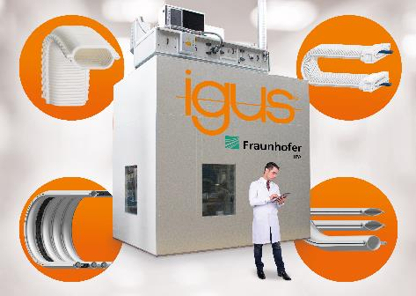
Picture PM2820-1
New igus cleanroom laboratory, built by the Fraunhofer IPA, for the speedy development of particle-free motion plastics that are suitable for cleanrooms up to Air Cleanliness Class 1, according to ISO 14644-1. (Source: igus GmbH)

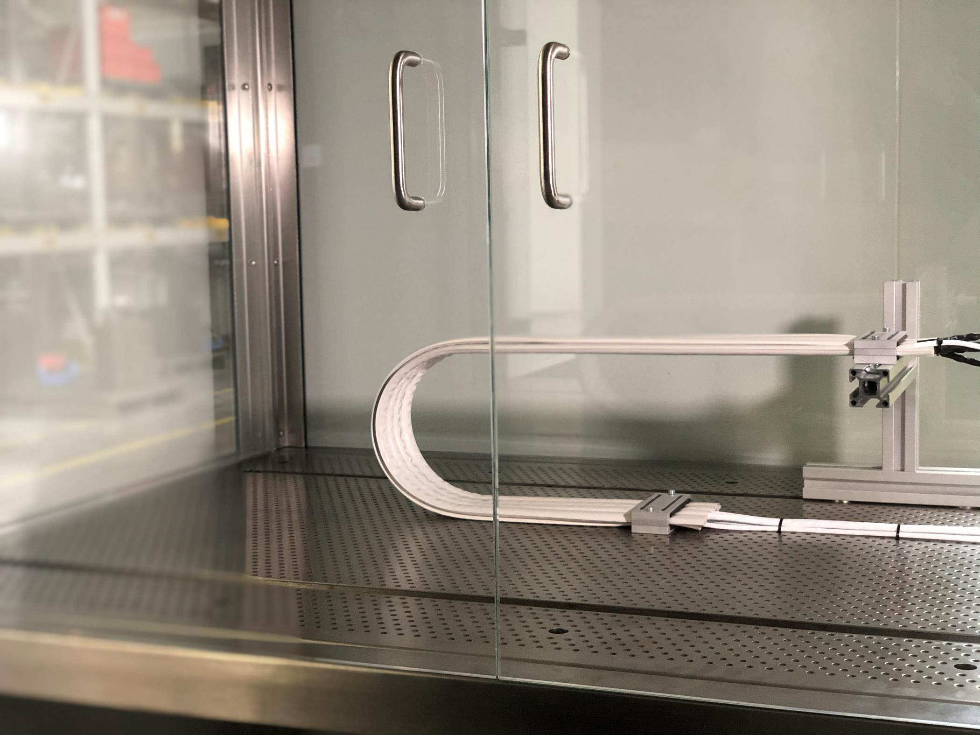
Picture PM2820-2
The tests of the e-skin energy supply systems, for example, take place in modular laminar flow boxes in accordance with ISO 14644-14 conditions. (Source: igus GmbH)

PRESS CONTACT:  Oliver Cyrus  Head of PR and Advertising  Anja Görtz-Olscher  PR and Advertising  igus® GmbH  Spicher Str. 1a  51147 Cologne  Tel. 0 22 03 / 96 49-459 or -7153  Fax 0 22 03 / 96 49-631  ocyrus@igus.net  agoertz@igus.net  www.igus.eu/press | ABOUT IGUS:  igus GmbH is a global leading manufacturer of energy chain systems and polymer plain bearings. The Cologne-based family business has offices in 35 countries and employs 4,150 people around the world. In 2019, igus generated a turnover of 764 million euros from motion plastics, plastic components for moving applications. igus operates the largest test laboratories and factories in its sector to offer customers quick turnaround times on innovative products and solutions tailored to their needs.

The terms "igus", “Apiro”, "chainflex", "CFRIP", "conprotect", "CTD", "drylin", "dry-tech", "dryspin", "easy chain", "e-chain", "e-chain systems", "e-ketten", "e-kettensysteme", "e-skin", "e-spool”, "flizz", “ibow”, “igear”, "iglidur", "igubal", “kineKIT”, "manus", "motion plastics", "pikchain", "plastics for longer life", "readychain", "readycable", “ReBeL”, "speedigus", "triflex", "robolink", “xirodur”, and "xiros" are protected by trademark laws in the Federal Republic of Germany and internationally, where applicable.

