Swimming pool on demand
Conmag Engineering transforms the terrace into a pool with the help of corrosion-free igus linear technology and saves €30,000

The touch of a button transforms a luxury swimming pool into a walk-in terrace. The key is a moving pool bottom from Conmag Engineering. But what linear technology works reliably and with little maintenance under water? The engineers found the answer at igus, saving €30,000 per pool.

Sitting on the terrace at 38 degrees Celsius in summer, dreaming of a swimming pool. Many people whose garden is too small for a pool know the feeling. The solution provided by Austria-based Conmag Engineering GmbH is a pool that is also a terrace. The key is its moving pool floor. In its top position, it is strong enough to walk on. But if its owners are tired of sitting in their sun loungers and are ready for a plunge into cool water, they can take one at the touch of a button. The bottom descends to a maximum depth of 1.5 metres, exposing the water, which is already at a pleasant temperature. The floor has a ten-centimetre insulating layer on its underside to minimise heat loss. An integrated counter-current system even allows for a brisk swim in place - without having to continuously reverse direction.

Hard-to-reach linear technology must be maintenance-free
As simple and elegant as the Austrian swimming pool may appear, building the moving bottom was a technical challenge. "The core competence was implementing a linear movement that was as constant, precise and reliable as possible," says Gerhard Rosskogler, Product Manager for High-Pressure Technology at Conmag. A gap of eight millimetres had to be maintained. "When the bottom lowers, the aim is to keep water displacement forces as low as possible to ensure sustainable design without endangering system strength." However, that was not all. "Since the entire mechanism is under water and very difficult to access, all bearings must be maintenance-free and as low-wear as possible."

igus linear guidance works without lubrication and is chlorine-resistant
Corrosion-free linear guidance seemed up to the task. The design engineers immediately began the first tests. "The igus experts gave us very competent advice and made processing very quick," says Rosskogler. "We immediately received free component samples and were able to start a test set-up quickly. This meant that we had a much longer test phase and were ultimately able to give the customer a mature product." The adjustment mechanism now works as follows: lead screws are installed in all four corners of the pool. They move the floor up and down - safely guided with igus drylin R linear guides with corrosion-free stainless-steel shafts mounted on drylin OXUM-06 series pillow blocks made of anodised aluminium. XUM plastic plain bearing liners made of the igus iglidur X polymer ensure low-friction movement. The liners are resistant to high loads and chemicals, have low moisture absorption and feature wear resistance under water.

Cost reduction of around €30,000 per pool
igus linear technology helped Conmag Engineering kill several birds with one stone. First, maintenance on the adjustment mechanism is practically zero. Microscopic solid lubricants are integrated into the plastic plain bearing liners, ensuring low-friction dry operation without external lubrication. This eliminates lubrication work, and there is no danger that grease will contaminate the water. Second, all mechanism components work reliably even in constant contact with water and chlorine. "The combination of stainless steel and high-performance plastics makes corrosion unthinkable," says Michael Hornung, Product Manager for drylin Linear and Drive Technology at igus. Also, the plastic absorbs very little moisture. "This guarantees reliable, maintenance-free operation for many years." Third, cost is reduced. "With igus linear technology, each pool costs around €30,000 less than previously," says Rosskogler.

Caption:

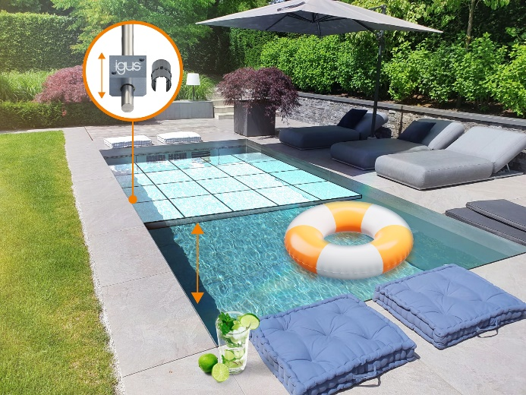
Picture PM4523-1
Austria-based Conmag Engineering GmbH has developed a pool with a moving pool floor for homeowners with small gardens. (Source: Conmag Engineering GmbH)

PRESS CONTACT:

Alexa Heinzelmann
Head of International Marketing

igus® GmbH
Spicher Str. 1a
51147 Cologne
Tel. 0 22 03 / 96 49-7272
aheinzelmann@igus.net
www.igus.eu/press

ABOUT IGUS:

igus GmbH develops and produces motion plastics. These lubrication-free, high-performance polymers improve technology and reduce costs wherever things move. In energy supplies, highly flexible cables, plain and linear bearings as well as lead screw technology made of tribo-polymers, igus is the worldwide market leader. The family-run company based in Cologne, Germany, is represented in 31 countries and employs 4,600 people across the globe. In 2022, igus generated a turnover of €1,15 billion. Research in the industry's largest test laboratories constantly yields innovations and more security for users. 234,000 articles are available from stock and the service life can be calculated online. In recent years, the company has expanded by creating internal startups, e.g. for ball bearings, robot drives, 3D printing, the RBTX platform for Lean Robotics and intelligent "smart plastics" for Industry 4.0. Among the most important environmental investments are the "chainge" programme – recycling of used e-chains - and the participation in an enterprise that produces oil from plastic waste.

The terms "igus", “Apiro”, "chainflex", "CFRIP", "conprotect", "CTD", “drygear”, "drylin", "dry-tech", "dryspin", "easy chain", "e-chain", "e-chain systems", "e-ketten", "e-kettensysteme", "e-skin", "e-spool”, "flizz", “ibow”, “igear”, "iglidur", "igubal", “kineKIT”, "manus", "motion plastics", "pikchain", "plastics for longer life", "readychain", "readycable", “ReBeL”, "speedigus", "tribofilament“, "triflex", "robolink", “xirodur”, and "xiros" are protected by trademark laws in the Federal Republic of Germany and internationally, where applicable.

