Print strong, abrasion-resistant parts easily yourself with the new igus tribo-filament
Easy-to-machine iglidur I190 FDM filament ensures fast manufacture of extremely wear-resistant parts

To manufacture wear-resistant parts in special dimensions quickly and cost-effectively, igus has now developed a new, easy-to-machine all-rounder filament: iglidur I190. It is remarkable for its great mechanical flexural strength (80 MPa). The tribologically optimised material requires no lubrication or maintenance and can be used with all commercially available 3D printers with heated printing plates.

In jig construction or assembly aids, users are always looking for sliding, wear-resistant special parts that optimise production operation. The parts are often quick to design, but custom manufacture with injection moulding or mechanical processing involves a great deal of cost and effort and is very expensive for small batches. More and more companies are therefore manufacturing their special parts on 3D printers. To print highly resilient parts the plastics specialist igus has now developed a new all-rounder material. "iglidur I190 is remarkable primarily for its great strength, making even delicate structures in the printed component strong", says Tom Krause, Head of the Additive Manufacturing department at igus GmbH. iglidur I190 is also suited to the design of multi-material sliding components because it combines very well with very rigid materials. The new lubrication-free filament can be machined very easily on all commercially available closed 3D printers with heated printing plates. The printed parts can even be used at temperatures of up to 90°C.

iglidur I190 easily outperforms standard plastics in tests
The new material proved its durability in a test in igus's 3,800 square metre in-house laboratory. A 3D printed iglidur I190 plain bearing was tested against bearings made of ABS and polyamide from additive manufacture and against turned and injection-moulded bearings made of POM and nylon. The results showed that the printed igus bearing had up to 50 times the abrasion resistance of the bearings made of standard plastics. iglidur I190 did well in internal competition as well – 80 to 46 MPa of flexural strength over food-compatible iglidur I150 filament. igus currently has a total of eight filaments for the FDM process and three high-performance polymers for the SLS process. The user can either order the material and use it with their own 3D printer or use the igus 3D printing service. For the latter, they can simply upload the STEP file directly to the shop, select the material, enter the desired quantity and submit the order. Within just three to five days, the wear-resistant special part will be delivered.

PRESS CONTACT:  Oliver Cyrus  Head of PR and Advertising  Anja Görtz-Olscher  PR and Advertising  igus® GmbH  Spicher Str. 1a  51147 Cologne  Tel. 0 22 03 / 96 49-459 or -7153  Fax 0 22 03 / 96 49-631  ocyrus@igus.net  agoertz@igus.net  www.igus.eu/press | ABOUT IGUS:  igus GmbH develops and produces motion plastics. These lubrication-free, high-performance polymers improve technology and reduce costs wherever things move. In energy supplies, highly flexible cables, plain and linear bearings as well as lead screw technology made of tribo-polymers, igus is the worldwide market leader. The family-run company based in Cologne, Germany, is represented in 35 countries and employs 3,800 people across the globe. In 2019, igus generated a turnover of €764 million. Research in the industry's largest test laboratories constantly yields innovations and more security for users. 234,000 articles are available from stock and the service life can be calculated online. In recent years, the company has expanded by creating internal startups, e.g. for ball bearings, robot drives, 3D printing, the RBTX platform for Lean Robotics and intelligent "smart plastics" for Industry 4.0. Among the most important environmental investments are the "chainge" programme – recycling of used e-chains - and the participation in an enterprise that produces oil from plastic waste. (Plastic2Oil).

The terms "igus", “Apiro”, "chainflex", "CFRIP", "conprotect", "CTD", “drygear”, "drylin", "dry-tech", "dryspin", "easy chain", "e-chain", "e-chain systems", "e-ketten", "e-kettensysteme", "e-skin", "e-spool”, "flizz", “ibow”, “igear”, "iglidur", "igubal", “kineKIT”, "manus", "motion plastics", "pikchain", "plastics for longer life", "readychain", "readycable", “ReBeL”, "speedigus", "tribofilament“, "triflex", "robolink", “xirodur”, and "xiros" are protected by trademark laws in the Federal Republic of Germany and internationally, where applicable.

Captions:

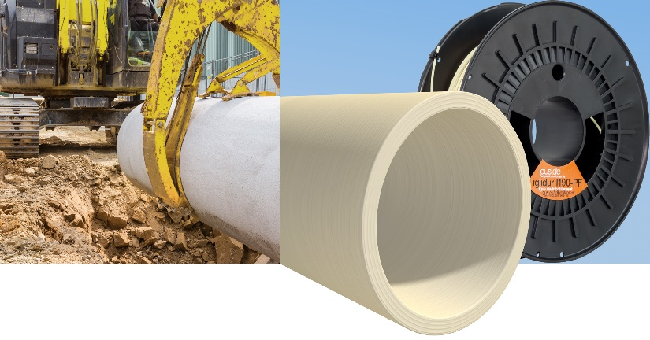
Picture PM0821-1
igus has developed a new all-rounder filament for 3D printing: iglidur I190. It allows printing wear-resistant special parts such as plain bearings with great mechanical flexural strength (80 MPa). (Source: igus GmbH)

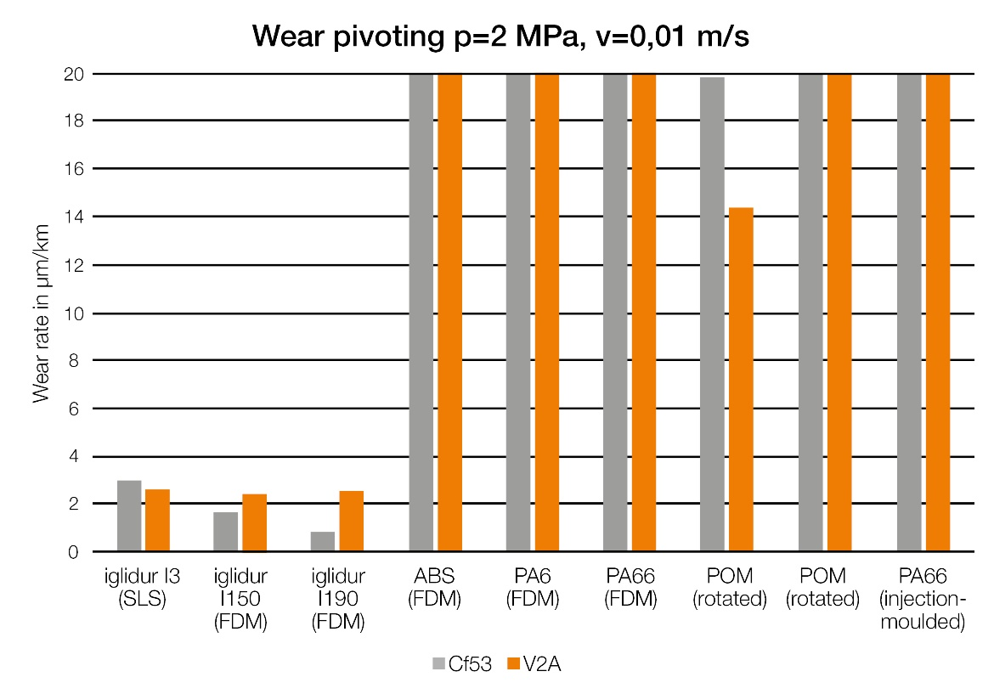
Picture PM0821-2
A printed iglidur I190 bearing was tested against bearings made of ABS and polyamide from additive manufacture and against turned and injection-moulded bearings made of POM and nylon. The results showed that the printed igus bearing had up to 50 times the abrasion resistance of the bearings made of standard plastics. (Source: igus GmbH)

