How igus makes it easier for industrial companies to get started with the Internet of Things
smart plastics specialist igus is a new member of the Berlin-based IoT Use Case expert network

The Internet of Things has growth potential of trillions of euros. But many industrial companies are having difficulty digitalizing their processes. As a new member of the Berlin-based IoT Use Case expert network, igus explains how to get started with IoT.

Monday morning in a bread factory: The packaging system suddenly breaks down. A minor component has failed, resulting in potentially long downtime and high repair costs. The most annoying thing about it is that a small investment in digitalization and networking would have been enough to implement measures to warn the operator of the problem through the Internet of Things. Smart condition monitoring is something that, despite its economic efficiency, few companies in Germany are implementing. This lethargy is confirmed in a survey by International Data Corporation (IDC), a US market research company. Of 250 companies surveyed with over 100 employees, only 29 percent are working on Internet of Things (IoT) projects. "To accelerate the pace of digitalization, we joined the Berlin-based IoT Use Case network of experts in October 2022," says Richard Habering, head of the smart plastics business unit at igus. "By doing educational work with best practice examples, sharing expertise, and generating synergy effects, we hope to make it easier for companies to get into the Internet of Things and enhance their future competitiveness."
"Companies should set the right course for digitalization at an early stage"
More than 80 industrial partners from more than 15 countries have now joined the community of technology and industry experts, including Microsoft, Siemens, and Schaeffler. "Only if we share best practices from our projects and talk specifically about the value IoT adds we will be successful here – no fancy PowerPoint slides!" says IoT Use Case founder Madeleine Mickeleit. The experts share knowledge about the Internet of Things and discuss how to improve the quality, security, and dissemination of IoT technology. Interested companies can read over 350 use cases and projects from the network, follow expert podcasts, and easily exchange ideas with like-minded companies. The Internet of Things has enormous potential for the economy. According to McKinsey, the value potential in factory environments will rise to 3.3 trillion dollars by 2030. "So it is important for companies to set the right course for digitalization now so they do not fall behind in international competition," says Habering.

igus will enrich the network, adding its smart plastics expertise
smart plastics are sensor systems that monitor the status of energy chains and cables, enabling technicians to plan maintenance work in a targeted manner and react early to impending component failures. Among the users – which can be found as use cases on the network website – is GHD Georg Hartmann Maschinenbau. The company has equipped a bread packaging machine with igus i.Sense CF.Q. In real time, the sensor system monitors the energy and data cables moving at high speed in the energy chains. Says Habering: "i.Sense CF.Q's advanced technology detects impending cable breaks before they occur." Visitors to the SPS automation trade show in Nuremberg will also be able to see this technology for themselves. From 8 to 11 November 2022, igus will be showing products from the smart plastics sector – including i.Sense TR.B, an intelligent condition monitoring system for 3D energy chains on industrial robots; the low-cost i.Sense EC.W service life sensor; and its latest i.Sense CF.D prototype for monitoring heavily used data cables. An IoT Use Case community meeting will also be held at the trade show.

Caption:

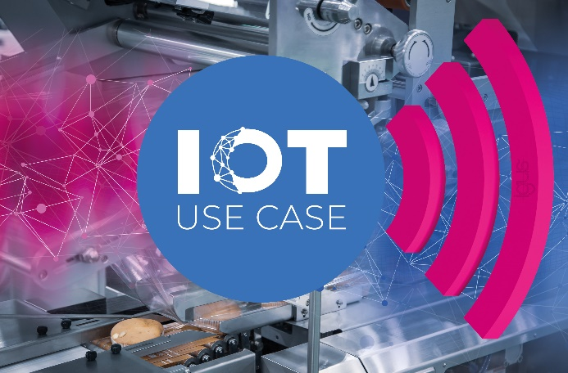
Picture PM6422-1
In the IoT Use Case network, igus will work with other companies to accelerate the digitalization of industry, from bread factories to train washing stations. (Source: igus GmbH)

PRESS CONTACT:

Alexa Heinzelmann
Head of International Marketing

igus® GmbH
Spicher Str. 1a
51147 Cologne
Tel. 0 22 03 / 96 49-7272
aheinzelmann@igus.net
www.igus.eu/press

ABOUT IGUS:

igus GmbH develops and produces motion plastics. These lubrication-free, high-performance polymers improve technology and reduce costs wherever things move. In energy supplies, highly flexible cables, plain and linear bearings as well as lead screw technology made of tribo-polymers, igus is the worldwide market leader. The family-run company based in Cologne, Germany, is represented in 31 countries and employs 4,900 people across the globe. In 2021, igus generated a turnover of €961 million. Research in the industry's largest test laboratories constantly yields innovations and more security for users. 234,000 articles are available from stock and the service life can be calculated online. In recent years, the company has expanded by creating internal startups, e.g. for ball bearings, robot drives, 3D printing, the RBTX platform for Lean Robotics and intelligent "smart plastics" for Industry 4.0. Among the most important environmental investments are the "chainge" programme – recycling of used e-chains - and the participation in an enterprise that produces oil from plastic waste.

The terms "igus", “Apiro”, "chainflex", "CFRIP", "conprotect", "CTD", “drygear”, "drylin", "dry-tech", "dryspin", "easy chain", "e-chain", "e-chain systems", "e-ketten", "e-kettensysteme", "e-skin", "e-spool”, "flizz", “ibow”, “igear”, "iglidur", "igubal", “kineKIT”, "manus", "motion plastics", "pikchain", "plastics for longer life", "readychain", "readycable", “ReBeL”, "speedigus", "tribofilament“, "triflex", "robolink", “xirodur”, and "xiros" are protected by trademark laws in the Federal Republic of Germany and internationally, where applicable.

