igus is looking for unique applications with energy chain systems
Applications for the ninth vector award are now being accepted/deadline: 9th February 2024

Calling engineers from all over the world: the igus vector award is entering its next round. For the ninth time, igus is honouring design engineers and project managers for creative, courageous use of energy supply systems and cables made of high-performance plastic. Winners will receive prize money of up to €5,000.

Artificial intelligence, machine learning and Industry 4.0 are trending topics in the media and the public. "But it’s easy to forget that engineers are making amazing progress in other relatively inconspicuous areas as well - in cable and hose guidance in machines and systems, for instance," says Michael Blass, CEO e-chain Systems at igus. This is requiring more and more skill and expertise on the part of design engineers. Customers are demanding more than ever before: hydraulic hoses weighing tons that move in a fail-safe manner over more than 1km - in gigantic bucket wheel excavators, for example. Data cables that can follow the wildest of 3D movements on articulated arm robots in factories. Energy chain systems that meet the strictest cleanroom requirements in the world in electronics production. Control cables that can fit in even the smallest installation spaces, barely larger than a cigar box. "Every day, we see how design engineers around the world implement extraordinary ideas with our energy chains and cables to meet increasingly stringent requirements. And long-lasting e-chain systems contribute greatly to sustainability," says Blass. "We are honouring these solutions, which often stay under the radar but are increasingly influencing product cost-effectiveness, with the 2024 vector award."

On your mark: engineers from all countries, register
Engineers can now enter the competition for the vector at www.igus.eu/vector-award. The deadline for entries is 9th February 2024. A panel of expert judges drawn from science, specialist media, industrial trade shows and professional associations will then examine the project and reward the most powerful, extraordinary ideas characterised by courage and creativity. The winner will receive the golden vector trophy and €5,000 in prize money. Second place receives the silver vector and €2,500 and third place the bronze vector and €1,000. The green vector comes with €1,000 and goes to projects featuring sustainability. The vector awards ceremony in 2024 will be held at the Hannover Messe.

Expand your network, gain customers, explore career paths
igus is awarding the vector for the ninth time. The competition has been taking place every two years since 2008 and is enjoying increasing popularity worldwide. In 2022, 233 applications were sent in from 36 countries. Gepber Szinpad, a Hungarian company, won first place for a multifunctional hall with automated rows of chairs that change formation at the push of a button. Dercks Gartenbau received the green vector for developing a precise watering trolley for potted plants. "The vector award is also an excellent opportunity for engineers and companies to attract attention, expand their network and win new customers," says Blass. "With this in mind, we hope for many exciting projects this year as well."

Compete for the vector award now at: www.igus.eu/vector-award

Caption:

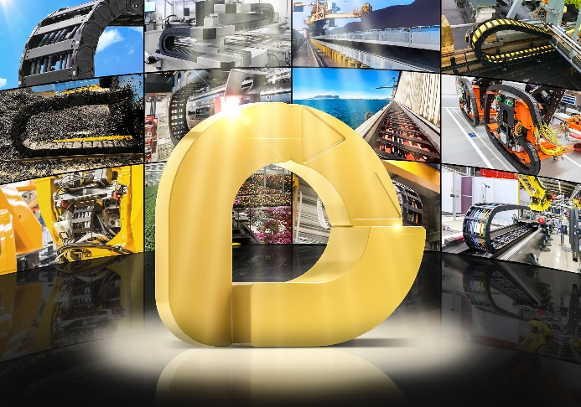
Picture PM5423-1
The vector award is entering its ninth round: igus is looking for exciting, creative, unique applications with energy chain systems. (Source: igus GmbH)
PRESS CONTACT:

Alexa Heinzelmann
Head of International Marketing

igus® GmbH
Spicher Str. 1a
51147 Cologne
Tel. 0 22 03 / 96 49-7272
aheinzelmann@igus.net
www.igus.eu/press

ABOUT IGUS:

igus GmbH develops and produces motion plastics. These lubrication-free, high-performance polymers improve technology and reduce costs wherever things move. In energy supplies, highly flexible cables, plain and linear bearings as well as lead screw technology made of tribo-polymers, igus is the worldwide market leader. The family-run company based in Cologne, Germany, is represented in 31 countries and employs 4,600 people across the globe. In 2022, igus generated a turnover of €1,15 billion. Research in the industry's largest test laboratories constantly yields innovations and more security for users. 234,000 articles are available from stock and the service life can be calculated online. In recent years, the company has expanded by creating internal startups, e.g. for ball bearings, robot drives, 3D printing, the RBTX platform for Lean Robotics and intelligent "smart plastics" for Industry 4.0. Among the most important environmental investments are the "chainge" programme – recycling of used e-chains - and the participation in an enterprise that produces oil from plastic waste.

The terms "igus", “Apiro”, "chainflex", "CFRIP", "conprotect", "CTD", “drygear”, "drylin", "dry-tech", "dryspin", "easy chain", "e-chain", "e-chain systems", "e-ketten", "e-kettensysteme", "e-skin", "e-spool”, "flizz", “ibow”, “igear”, "iglidur", "igubal", “kineKIT”, "manus", "motion plastics", "pikchain", "plastics for longer life", "readychain", "readycable", “ReBeL”, "speedigus", "tribofilament“, "triflex", "robolink", “xirodur”, and "xiros" are protected by trademark laws in the Federal Republic of Germany and internationally, where applicable.

