Go Zero Lubrication: the clean revolution in the industry with lubrication-free plastics
$990 billion spent on lubrication per year worldwide - at Hannover Messe 2024, igus demonstrates who can do without lubricants immediately and the role AI plays

Lubricants are as much a part of everyday industrial life as a cup of coffee every morning. Every year, 240 billion dollars are spent on lubricants across the globe. In addition, studies have shown significantly higher costs for maintenance personnel. Nevertheless, machine downtime worth 750 billion dollars occur every year due to inadequate lubrication. igus now combines 60 years of motion plastics expertise with hundreds of thousands of test data and millions of applications in an AI that immediately takes users to lubrication-free movements in their systems. From excavators and agricultural tractors to water turbines, everything has already been successfully tried and tested. A study by RWTH Aachen University demonstrates the explosive nature of the topic. At the Hannover Messe, the plastics specialist is presenting 247 new products, showing that everybody can achieve "zero lubrication".

People discussing the most important innovations of the future rarely mention a lubrication-free world. However, a study by RWTH Aachen University is the first to prove the positive impact that lubrication-free plastics have on companies' profitability and sustainability. One example of a world-renowned beer-bottler shows: by using lubrication-free polymer bearings in all conveyor belts at its 160 sites, the company was able to save €6 million a year otherwise spent on lubricant and staff. The positive environmental impact is also considerable: At the same time, annual CO₂ equivalents totalling 28,814kg could be saved. At Hannover Messe 2024, igus will be showcasing hundreds of proven applications that operate completely without lubrication for as long as the machines were designed – and often even longer. New products are constantly expanding the industry's possibilities, whether for linear guides, rollers, gears or gearboxes.

A clean revolution with artificial intelligence
"igus, make my excavator lubrication-free!": The prototype's new version of the igusGO app, which was presented for the first time last year, makes this possible. By voice, photo or text, users are now immediately shown the proven solutions for various points in their excavator and 600 other applications. If they cannot find their application, they can request it via AI chat in the app and are guaranteed to receive an answer. The AI is based on data from millions of applications of igus products over the past decades. It also provides functions for determining the application's service life in their individual scenario - based on hundreds of thousands of test values from the in-house laboratory, which igus describes as the largest of its kind in the world. "Today's role of AI is overwhelming," says Tobias Vogel, CEO of Plain Bearings and Linear Technology at igus. "All of a sudden, we can turn all the 'zero lubrication' proof of the last decades into a safe and simple tool for everyone in the industry." Another brand-new feature is the calculation of saved lubricant in the igusGo app, which is indicated when users select a plain bearing or gear, for example. The "Next Best Catalogue Part" AI service is also new. If customers upload the CAD file of a plain bearing they have designed, which is to be installed in a bicycle without lubrication, for example, the AI automatically displays the catalogue part that comes closest to the special part. By using the catalogue part, the customer not only saves costs, but also benefits from fast delivery times. For even greater functional reliability, igus is now extending its 4-year guarantee for chainflex cables to all other motion plastics products with an online service life calculation.

247 innovations for zero lubrication
In total, igus is launching 247 new products in time for Hannover Messe 2024 - many of them in line with the principle "Go Zero Lubrication". igus offers a further three product series of high-load plain bearings for construction machinery, cranes and agricultural machinery, all of which have been tested and proven in practice. One of them is based on regranulated igus plastics from production waste. The new PTFE- and PFAS-free materials for plain and linear bearings as well as a new slewing ring bearing made of 50 per cent wood and 50 per cent high-performance plastic are also important components for real sustainability. New, separable igubal flange mounted bearings reduce the time it takes to replace lubricated ball bearings by up to 80 per cent, for example in conveyor belts with bearings close to the motor. New 3D printing materials and liners combine freedom from lubrication with explosion protection ("ESD capability"). In the same way, a new series of linear systems in hygienic design merges food suitability with "zero lubrication". In terms of intelligent condition monitoring, an abrasion sensor for spherical bearings now complements the existing smart plastics solutions for bearing technology. The final innovative example is a completely new evoloid gearbox. It works with electric drives with an 18:1 transmission in one stage, requires less installation space, costs 70 per cent less than metallic versions and requires no lubricating greases or oils. "We are looking forward to the dialogue with users at the Hannover Messe, where they can experience all of this live and try it out for themselves," says Tobias Vogel. "We are certain that we can already avoid at least 10 per cent of global lubrication costs. And the 'Zero Lubrication' journey continues - we still have a lot of development work to do."

Caption:

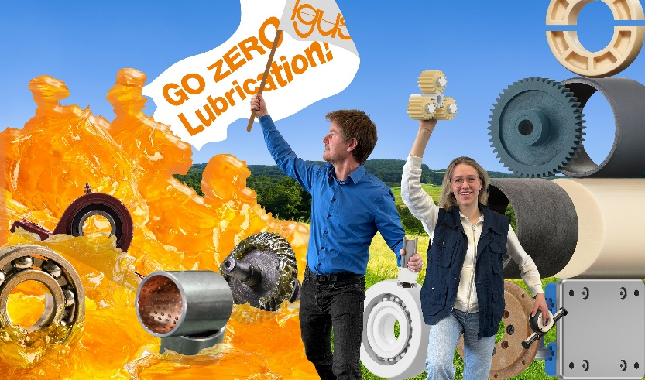
Picture PM1924-1
Revolution in industry: at this year's Hannover Messe, igus will be showing who can immediately do without lubricants and what role AI plays in this. (Source: igus GmbH)

PRESS CONTACT:

Alexa Heinzelmann
Head of International Marketing

igus® GmbH
Spicher Str. 1a
51147 Cologne
Tel. 0 22 03 / 96 49-7272
aheinzelmann@igus.net
www.igus.eu/press

ABOUT IGUS:

igus GmbH develops and produces motion plastics. These lubrication-free, high-performance polymers improve technology and reduce costs wherever things move. In energy supplies, highly flexible cables, plain and linear bearings as well as lead screw technology made of tribo-polymers, igus is the worldwide market leader. The family-run company based in Cologne, Germany, is represented in 31 countries and employs 4,600 people across the globe. In 2022, igus generated a turnover of €1,15 billion. Research in the industry's largest test laboratories constantly yields innovations and more security for users. 234,000 articles are available from stock and the service life can be calculated online. In recent years, the company has expanded by creating internal startups, e.g. for ball bearings, robot drives, 3D printing, the RBTX platform for Lean Robotics and intelligent "smart plastics" for Industry 4.0. Among the most important environmental investments are the "chainge" programme – recycling of used e-chains - and the participation in an enterprise that produces oil from plastic waste.

The terms "igus", “Apiro”, "chainflex", "CFRIP", "conprotect", "CTD", “drygear”, "drylin", "dry-tech", "dryspin", "easy chain", "e-chain", "e-chain systems", "e-ketten", "e-kettensysteme", "e-skin", "e-spool”, "flizz", “ibow”, “igear”, "iglidur", "igubal", “kineKIT”, "manus", "motion plastics", "pikchain", "plastics for longer life", "readychain", "readycable", “ReBeL”, "speedigus", "tribofilament“, "triflex", "robolink", “xirodur”, and "xiros" are protected by trademark laws in the Federal Republic of Germany and internationally, where applicable.

