It's all in the mix! igus presents new slewing ring bearing made of wood and plastic
Sustainability meets innovative technology - igus presents slewing ring bearings made of WPC at the Hannover Messe

With the new slewing ring bearing made of WPC (wood-plastic composite), igus is taking another step forward in the integration of renewable raw materials in industrial production. By using 50 per cent wood and 50 per cent high-performance plastics, customers receive a cost-effective and lubrication-free slewing ring bearing. It strikes a good balance between strength, durability and environmental friendliness with a proven low CO₂ footprint.

How can renewable raw materials also be put to meaningful use in industry? The plastics specialist igus has considered this question and has now developed an iglidur PRT slewing ring bearing made of wood-plastic composite (WPC for short) for the first time. "As a plastics expert, we are now also venturing into the wood sector. Last year, we presented wooden shafts as possible mating partners for our linear guides for the first time. This year, we are integrating the wood directly into our products," explains Marc Trenkler, Product Manager for Slewing Ring Bearings at igus GmbH. Here, igus can rely on its proven injection moulding. The new PRT consists of WPC, a mixture of wood fibres and iglidur high-performance plastics. The materials incorporate solid lubricants that make the slewing ring bearing smooth-running, lubrication-free and maintenance-free. The wood content gives the whole thing a natural look. Both the housing and the component are made of the WPC material. It only takes four screws to connect the two parts.

Cost-effective, low CO₂ footprint, tried and tested
Developed specifically for the standard installation size PRT 02, the slewing ring bearing from igus is an equally priced alternative to the cost-effective PRT made of solid plastic, without compromising on performance. It allows for easy adjusting, for example in furniture technology, while offering a robust design that fulfils the requirements of various applications. A special feature of this new product is its extremely low CO₂ footprint of just 0.0577kg. By comparison, the PRT-02-30-ECO, which is already made from 97 per cent regranulate, has a CO₂ equivalent of 0.819868kg. To ensure the reliability and performance of the new slewing ring bearing, it was subjected to extensive tests under real conditions in the 3,800m² igus laboratory. These analyses confirm the high quality and reliability of the product under various operating conditions.

Caption:

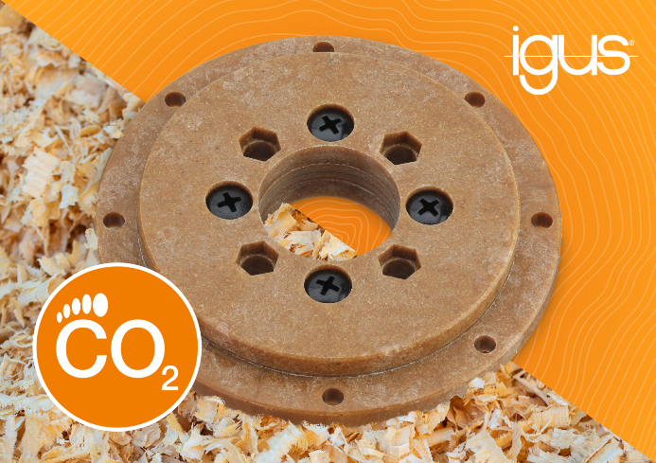
Picture PM2024-1
The new igus slewing ring bearing made of WPC impresses not only with its wooden look, but above all with its low CO₂ footprint. (Source: igus GmbH)

PRESS CONTACT:

Alexa Heinzelmann
Head of International Marketing

igus® GmbH
Spicher Str. 1a
51147 Cologne
Tel. 0 22 03 / 96 49-7272
aheinzelmann@igus.net
www.igus.eu/press

ABOUT IGUS:

igus GmbH develops and produces motion plastics. These lubrication-free, high-performance polymers improve technology and reduce costs wherever things move. In energy supplies, highly flexible cables, plain and linear bearings as well as lead screw technology made of tribo-polymers, igus is the worldwide market leader. The family-run company based in Cologne, Germany, is represented in 31 countries and employs about 5,000 people across the globe. In 2023, igus generated a turnover of €1,136 billion. Research in the industry's largest test laboratories constantly yields innovations and more security for users. 243,000 articles are available from stock and the service life can be calculated online. In recent years, the company has expanded by creating internal startups, e.g. for ball bearings, robot drives, 3D printing, the RBTX platform for Lean Robotics and intelligent "smart plastics" for Industry 4.0. Among the most important environmental investments are the "chainge" programme – recycling of used e-chains - and the participation in an enterprise that produces oil from plastic waste.

The terms "igus", “Apiro”, "chainflex", "CFRIP", "conprotect", "CTD", “drygear”, "drylin", "dry-tech", "dryspin", "easy chain", "e-chain", "e-chain systems", "e-ketten", "e-kettensysteme", "e-skin", "e-spool”, "flizz", “ibow”, “igear”, "iglidur", "igubal", “kineKIT”, "manus", "motion plastics", "pikchain", "plastics for longer life", "readychain", "readycable", “ReBeL”, "speedigus", "tribofilament“, "triflex", "robolink", “xirodur”, and "xiros" are protected by trademark laws in the Federal Republic of Germany and internationally, where applicable.

