igus is once again looking for creative Low Cost Automation projects with the fastest return on investment
igus launches application phase for the third ROIBOT Award 2024

The German economy is weakening and will only recover slowly in 2024, according to the Institute for Macroeconomics and Business Cycle Research (IMK). The mechanical engineering industry is also feeling the effects. To strengthen competitiveness, organisations will have to focus on automation. Thanks to Low Cost Automation (LCA) and the RBTX robotics marketplace from igus, companies of all sizes can find a complete solution that suits their requirements and budget - from as little as €2,000. The plastics company is now honouring the projects with the fastest return on investment (ROI) with the ROIBOT Award for the third time. Users can now apply to win LCA products worth €5,000 in addition to international recognition.

In times of a weakening economy, both corporations and small and medium-sized enterprises (SMEs) are looking for automation solutions that are cost-effective and easy to implement. It is precisely this need that igus fulfils with LCA. The Cologne-based plastics specialist offers everything interested parties need for cost-effective process automation from a single source: from individual components and robots with peripherals to complete solutions for customised applications. The average investment costs here are €12,000. By way of comparison, an industrial robot can easily cost over €100,000, including control system, software and licences. "We are always amazed at the creative way in which companies use our components. From automated earthworm farms to robots that serve beer," states Alexander Mühlens, Head of the Low Cost Automation Business Unit at igus. However, many of these inventions receive too little attention. "Which is why we are organising the ROIBOT Award 2024. For the third time, we would like to offer a stage to LCA projects that demonstrate courage, creativity and out-of-the-box thinking." igus holds the competition with an international focus every two years. In 2022, 110 projects from 20 countries applied.

Starting signal for the application phase
Users can apply for the ROIBOT Award with their automation projects until 30th June 2024 at https://roibot.eu/roibot registration. igus offers support on request. A team of experts will create free video and image recordings of the application and supervise the staging. Participants thus skip the application process and are direct candidates for the competition. The prerequisite is that the LCA solutions work with components purchased from igus or via RBTX.com. These include, for example, articulated arm robots, Cartesian robots, delta robots and SCARA robots.

Winning low-cost automation products worth €5,000 and attracting attention
A jury consisting of representatives from the specialist press and industry experts selects the three best projects that stand out due to originality and a low ROI. The winner will receive LCA hardware worth €5,000, while the runners-up will be awarded €2,500 and €1,000. "The competition also offers participants international media attention and the opportunity to network with other automation enthusiasts, share experiences, gain inspiration and perhaps even explore new career opportunities. For example, investors were found for a young start-up at the last ROIBOT Award," concludes Mühlens. The winner of the ROIBOT Award 2022, MFG Technik & Service GmbH, also benefited from this. The company from Kranzberg near Munich convinced the jury with its Label Monkey, a LCA solution that labels industrial pallets from three sides using the robolink DP robot arm from igus.

Caption:
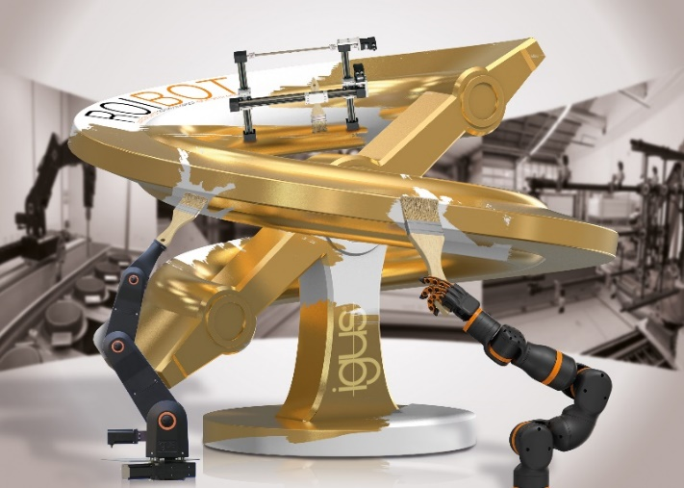
Picture PM0124-1
Whether cobot, articulated arm robot or flat linear robot: igus honours clever and creative LCA projects with the ROIBOT Award for the third time. (Source: igus GmbH)

PRESS CONTACT:

Alexa Heinzelmann
Head of International Marketing

igus® GmbH
Spicher Str. 1a
51147 Cologne
Tel. 0 22 03 / 96 49-7272
aheinzelmann@igus.net
www.igus.eu/press

ABOUT IGUS:

igus GmbH develops and produces motion plastics. These lubrication-free, high-performance polymers improve technology and reduce costs wherever things move. In energy supplies, highly flexible cables, plain and linear bearings as well as lead screw technology made of tribo-polymers, igus is the worldwide market leader. The family-run company based in Cologne, Germany, is represented in 31 countries and employs 4,600 people across the globe. In 2022, igus generated a turnover of €1,15 billion. Research in the industry's largest test laboratories constantly yields innovations and more security for users. 234,000 articles are available from stock and the service life can be calculated online. In recent years, the company has expanded by creating internal startups, e.g. for ball bearings, robot drives, 3D printing, the RBTX platform for Lean Robotics and intelligent "smart plastics" for Industry 4.0. Among the most important environmental investments are the "chainge" programme – recycling of used e-chains - and the participation in an enterprise that produces oil from plastic waste.

The terms "igus", “Apiro”, "chainflex", "CFRIP", "conprotect", "CTD", “drygear”, "drylin", "dry-tech", "dryspin", "easy chain", "e-chain", "e-chain systems", "e-ketten", "e-kettensysteme", "e-skin", "e-spool”, "flizz", “ibow”, “igear”, "iglidur", "igubal", “kineKIT”, "manus", "motion plastics", "pikchain", "plastics for longer life", "readychain", "readycable", “ReBeL”, "speedigus", "tribofilament“, "triflex", "robolink", “xirodur”, and "xiros" are protected by trademark laws in the Federal Republic of Germany and internationally, where applicable.

