Even more reliability over long travels thanks to the new igus i.Sense EC.B rope hoist sensor for e-chains
One instead of two: condition monitoring for chains of 35 metres or more now with a single sensor

Loads, high speeds and the most adverse environmental conditions: energy chains often have to withstand severe stresses. Safe cable guidance is a challenge, e.g. for very long travels like those in large crane systems. To ensure even greater system safety in such cases, igus now offers users the i.Sense EC.B with a new rope hoist sensor for intelligent condition monitoring for chains of 35 metres or more.

Snow, ice, dirt, foreign bodies or a bent trough: there are a wide variety of external influences that can cause even the most robust, durable energy chain to break during operation. In order to avoid unplanned downtimes and the associated costs, the motion plastics specialist igus offers users the proven i.Sense EC.B system for e-chain condition monitoring. Potential chain breaks can be detected in a flash, even on very long travels. The new rope hoist sensor means that only a single sensor is now required for intelligent condition monitoring for chains of 35 metres or more. The measurement range extension from 80 to 999 millimetres eliminates the need for the second sensor on the fixed end side. The longer measurement path also offers better precision over long travels. If breakage is detected, the sensor immediately triggers a message, and the evaluation module sends a signal to the system's control unit. Two sensors (for reverse systems, for example) can also be connected to the new i.Sense GEN II evaluation module. If they are connected to the control system's digital I/O ports, they can also be used to trigger a rapid system shutdown. The new rope hoist sensor is compatible with all previously delivered EC.B systems and i.Sense modules, and can also be integrated into IIoT concepts.

Resistant to weather effects
The igus i.Sense system has already proven itself in many industries, e.g. in very dynamic applications in the automotive sector. But Industry 4.0 is increasing demands on machines and monitoring systems - as crane systems show. Cranes are working faster and faster as travel distances get longer and longer. This makes a robust, durable energy supply system that much more important. "We want crane operators to benefit from the positive i.Sense EC.B system experiences in the automotive industry," says Richard Habering, Head of Business Unit smart plastics at igus. "For safe, failure-free handling of lots of heavy cables in adverse environmental conditions, real-time status detection along the entire travel adds immense value for port or crane operators." In addition to the longer measuring distance, the new rope hoist sensor is characterised by extreme weather resistance and robustness, making it especially interesting for outdoor applications. Fully automated crane systems are particularly susceptible to unexpected downtimes because there is no driver to hear any warning signals. For optimum protection against unexpected failures, crane operators can use the reliable i.Sense EC.B monitoring system instead.

More reliability, lower costs
The igus smart system gives customers full control, a good overview and a reliable energy supply. This extends the service life of both the energy chain and the machine on which it is used. igus conducts ongoing test series in the industry's largest test laboratory for dynamic power transmission systems to continuously optimise the longevity of its motion plastics products. Early system failure warnings from the i.Sense EC.B system also greatly reduce costs: acquisition costs are lower, since only one sensor is required for real-time condition monitoring for chains of 35 metres or more, and maintenance costs can be reduced. Instead of maintaining their systems at regular intervals, companies can perform condition-based maintenance, avoiding unnecessary or early chain replacement.

Caption:

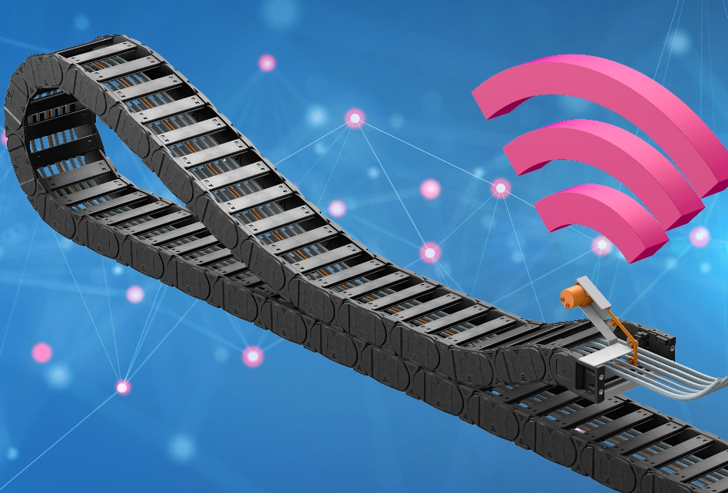
Picture PM4522-1
More reliability on long travels: the new i.Sense EC.B rope hoist sensor means that users need only one sensor for real-time condition monitoring for chains of 35 metres or more. (Source: igus GmbH)

PRESS CONTACT:

Alexa Heinzelmann
Head of International Marketing

igus® GmbH
Spicher Str. 1a
51147 Cologne
Tel. 0 22 03 / 96 49-7272
aheinzelmann@igus.net
www.igus.eu/press

ABOUT IGUS:

igus GmbH develops and produces motion plastics. These lubrication-free, high-performance polymers improve technology and reduce costs wherever things move. In energy supplies, highly flexible cables, plain and linear bearings as well as lead screw technology made of tribo-polymers, igus is the worldwide market leader. The family-run company based in Cologne, Germany, is represented in 35 countries and employs 4,900 people across the globe. In 2021, igus generated a turnover of €961 million. Research in the industry's largest test laboratories constantly yields innovations and more security for users. 234,000 articles are available from stock and the service life can be calculated online. In recent years, the company has expanded by creating internal startups, e.g. for ball bearings, robot drives, 3D printing, the RBTX platform for Lean Robotics and intelligent "smart plastics" for Industry 4.0. Among the most important environmental investments are the "chainge" programme – recycling of used e-chains - and the participation in an enterprise that produces oil from plastic waste.

The terms "igus", “Apiro”, "chainflex", "CFRIP", "conprotect", "CTD", “drygear”, "drylin", "dry-tech", "dryspin", "easy chain", "e-chain", "e-chain systems", "e-ketten", "e-kettensysteme", "e-skin", "e-spool”, "flizz", “ibow”, “igear”, "iglidur", "igubal", “kineKIT”, "manus", "motion plastics", "pikchain", "plastics for longer life", "readychain", "readycable", “ReBeL”, "speedigus", "tribofilament“, "triflex", "robolink", “xirodur”, and "xiros" are protected by trademark laws in the Federal Republic of Germany and internationally, where applicable.

