Lots of performance for little space: the new igus slewing ring bearing is particularly compact
The high-performing product series is being expanded further - with the lubrication-free iglidur PRT-04 micro slewing ring bearing for the tightest of installation spaces

Requirements for machine components are becoming increasingly stringent: installing drives and allowing movements in even the smallest of installation spaces is a challenge that companies are facing in many areas. Now igus has refined its PRT-04 slewing ring bearing series to suit these applications exactly - with an extremely compact slewing ring bearing for even more space savings.

Save installation space and weight without sacrificing performance reliability - while entirely eliminating lubrication. That's what the igus PRT-04 micro can do. igus is thus adding a particularly small slewing ring bearing that is also robust to its product range. The PRT-04 micro has an outer diameter of 60mm, the smallest installation size among igus PRT slewing ring bearings. It consists of three aluminium rings and a newly developed sliding element made of the proven iglidur J high-performance plastic, which operates especially well on aluminium, ensuring good coefficients of wear and a long service life. It also has low moisture absorption and good chemical resistance. Other materials can also be used, depending on individual customer requirements. Like all igus bearings, the PRT-04 micro is 100% lubrication-free and thus insensitive to dirt, dust and moisture.

A lightweight for moving applications
"Aluminium with plastic offers two decisive design advantages: it is lightweight, yet stable. Thus, despite its small size, the PRT-04 micro can hold its own against comparable products on the market and accommodate high loads (up to 3,500N) in the axial direction, even though it is much more compact", says Fabian Wieking, PRT Slewing Ring Bearing Product Manager at igus. This allows for smooth rotary and swivel movements in even smaller installation spaces, giving rise to a number of possible applications. The low weight is also highly relevant in all industries. Possible applications are small, movable lighting installations - so-called moving head applications - or swivelling tables in trains and aeroplanes, but also automotive applications. Low weight also pays off here in terms of fuel consumption. Less weight means less consumption - and thus another way to reach the goal of greater sustainability. Eliminating lubricants also adds value: maintaining equipment costs time and money, after all. The solid lubricants in the iglidur material not only mean that the slewing ring bearing works without greases and oils, they also eliminate the need for maintenance - all while making the slewing ring bearing particularly durable. Another advantage is that the PRT-04 micro is a ready-to-install part that can be integrated directly into an application. This eliminates design costs and DIY bearing points.

Ready to install or individually configurable: the best advice from PRT experts
Since 2019, igus has been offering users the PRT-04 slewing ring bearing series, an extensive and constantly growing modular system developed specifically for movements in confined spaces. It consists of a variety of combinable variants. The PRT expert provides assistance in selecting the right bearing: entering just a few parameters relating to installation space, load, speed and environment allows the configurator to find the right slewing ring bearing for the customer's individual application and calculate the expected service life in the same step. The service life is checked thoroughly in igus's own 3,800m² test laboratory. The data collected there is integrated into the PRT configurator, allowing a reliable statement about slewing ring bearing service life.

Caption:
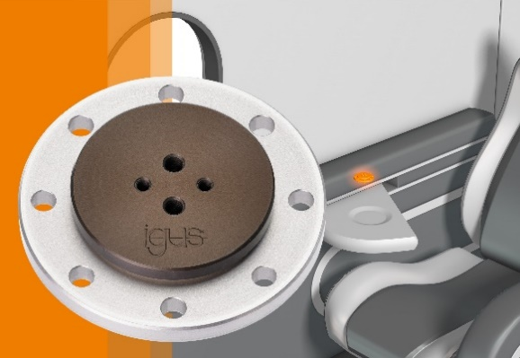
Picture PM1522-1
Small but mighty: the PRT-04 micro can be integrated into very small customer applications with absolutely no lubrication while still accommodating high loads. (Source: igus GmbH)

PRESS CONTACT:

Alexa Heinzelmann
Head of International Marketing

igus® GmbH
Spicher Str. 1a
51147 Cologne
Tel. 0 22 03 / 96 49-7272
aheinzelmann@igus.net
www.igus.eu/press

ABOUT IGUS:

igus GmbH develops and produces motion plastics. These lubrication-free, high-performance polymers improve technology and reduce costs wherever things move. In energy supplies, highly flexible cables, plain and linear bearings as well as lead screw technology made of tribo-polymers, igus is the worldwide market leader. The family-run company based in Cologne, Germany, is represented in 35 countries and employs 4,900 people across the globe. In 2020, igus generated a turnover of €727 million. Research in the industry's largest test laboratories constantly yields innovations and more security for users. 234,000 articles are available from stock and the service life can be calculated online. In recent years, the company has expanded by creating internal startups, e.g. for ball bearings, robot drives, 3D printing, the RBTX platform for Lean Robotics and intelligent "smart plastics" for Industry 4.0. Among the most important environmental investments are the "chainge" programme – recycling of used e-chains - and the participation in an enterprise that produces oil from plastic waste.

The terms "igus", “Apiro”, "chainflex", "CFRIP", "conprotect", "CTD", “drygear”, "drylin", "dry-tech", "dryspin", "easy chain", "e-chain", "e-chain systems", "e-ketten", "e-kettensysteme", "e-skin", "e-spool”, "flizz", “ibow”, “igear”, "iglidur", "igubal", “kineKIT”, "manus", "motion plastics", "pikchain", "plastics for longer life", "readychain", "readycable", “ReBeL”, "speedigus", "tribofilament“, "triflex", "robolink", “xirodur”, and "xiros" are protected by trademark laws in the Federal Republic of Germany and internationally, where applicable.

